**Description**

You can use Azure Database Migration Service to migrate the databases from a SQL Server instance to [Azure](https://github.com/MicrosoftDocs/azure-docs/blob/main/azure/sql-database) SQL Server. In this tutorial, you migrate the [Sample](https://github.com/MicrosoftDocs/azure-docs/blob/main/sql/samples/adventureworks-install-configure#download-backup-files) (Adventure Works) database from SQL Server 2019 to Azure SQL Server 2019 by using Azure Data Studio

In this Lab, you will learn how to:

* Use the Azure Data Studio to migrate the database sample data.
* Create a migration project by using Azure Data Studio.
* Run the migration.
* Monitor the migration.

**Learning Objectives**

Upon completion of this Lab, you will be able to:

* Migrate Azure SQL Server to Azure SQL Server (IaaS to IaaS)
* Connect to an Azure SQL database and SQL server through Azure Data Studio

**Intended Audience**

This lab is intended for:

* Microsoft CSA Team members

**Steps to carry out migration activity**

**Online Migration:**

**Login to Source VM by RDP**

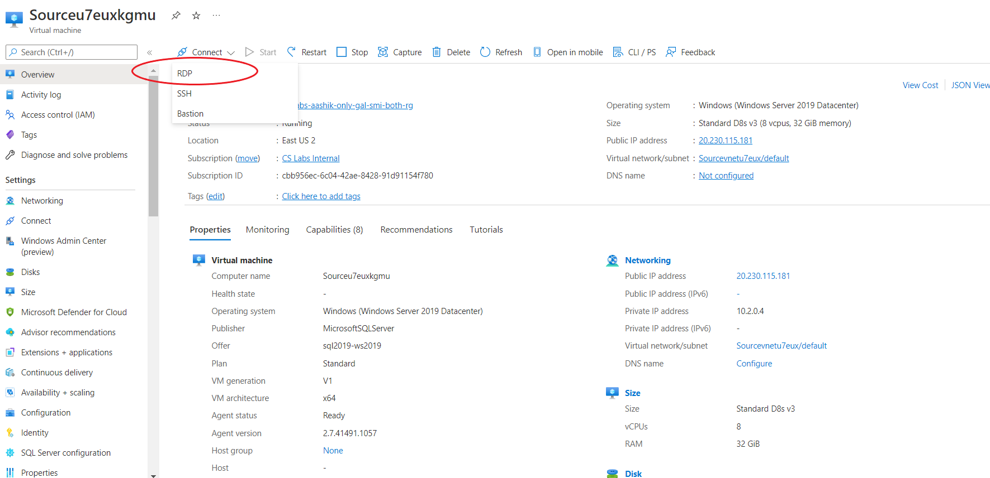

Select **RDP**

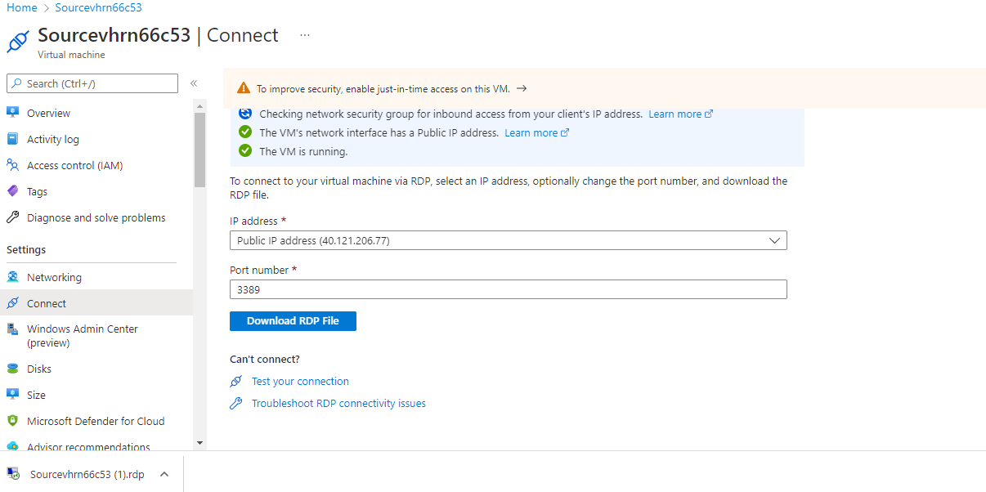

Select **Download RDP File**

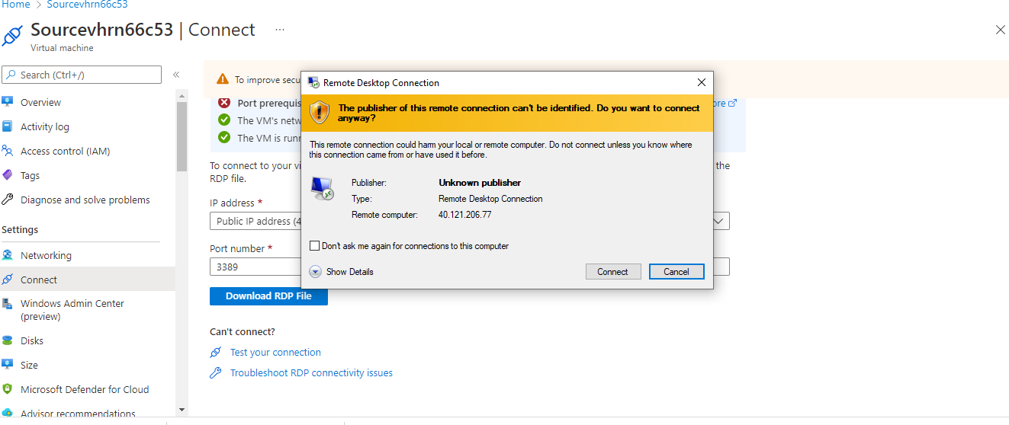

Select **Connect**

**Login to Source VM.**

Click on the downloaded RDP file and provide below credentials to login.

**Username**: sqladmin and **Password: Password@123**

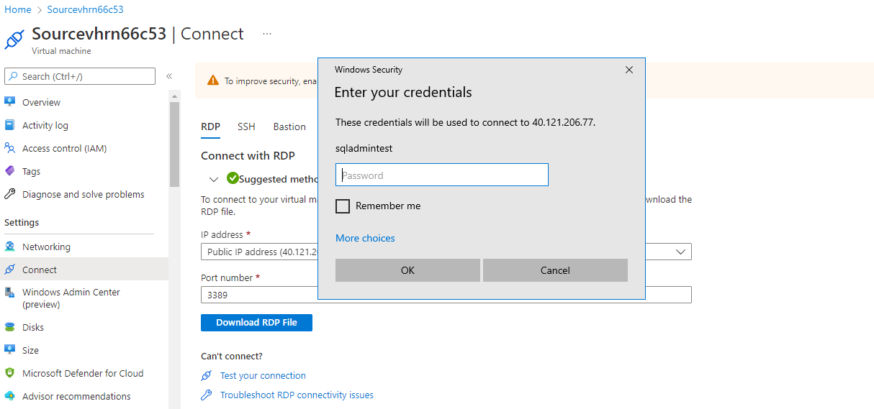

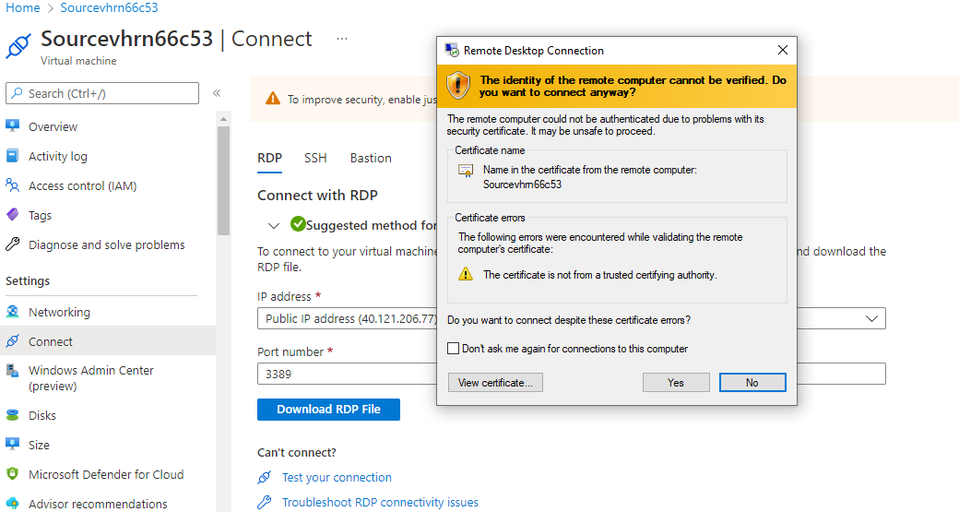

Click **Yes**

**After Login to SQL Source VM disable IE Enhanced Security Configuration**

Search for Server Manager from **Start** menu, Go to Dashboard and choose **Configure this local server.**

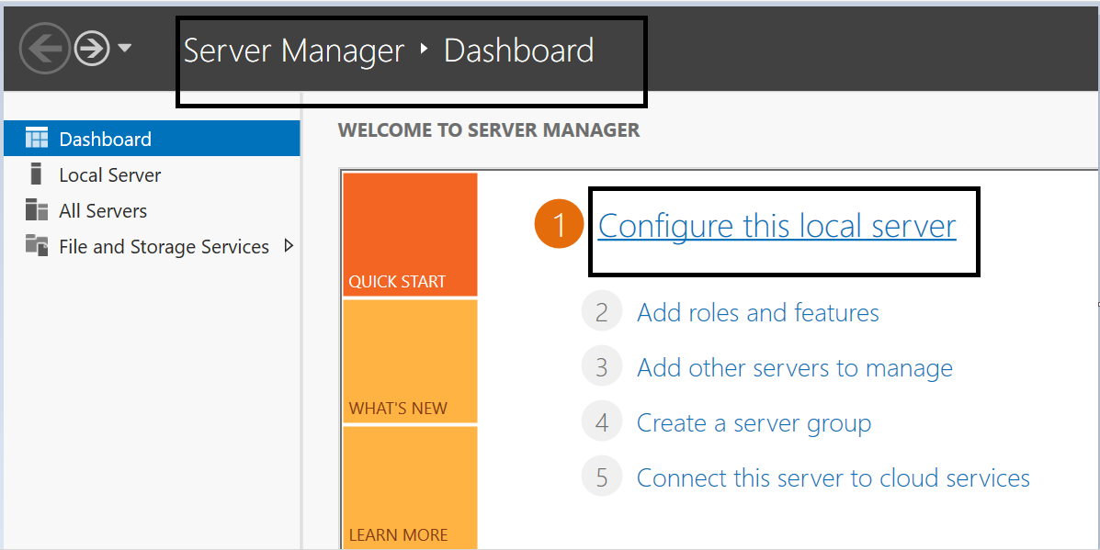

In properties pane navigate to IE enhanced security configuration and click on **On**.

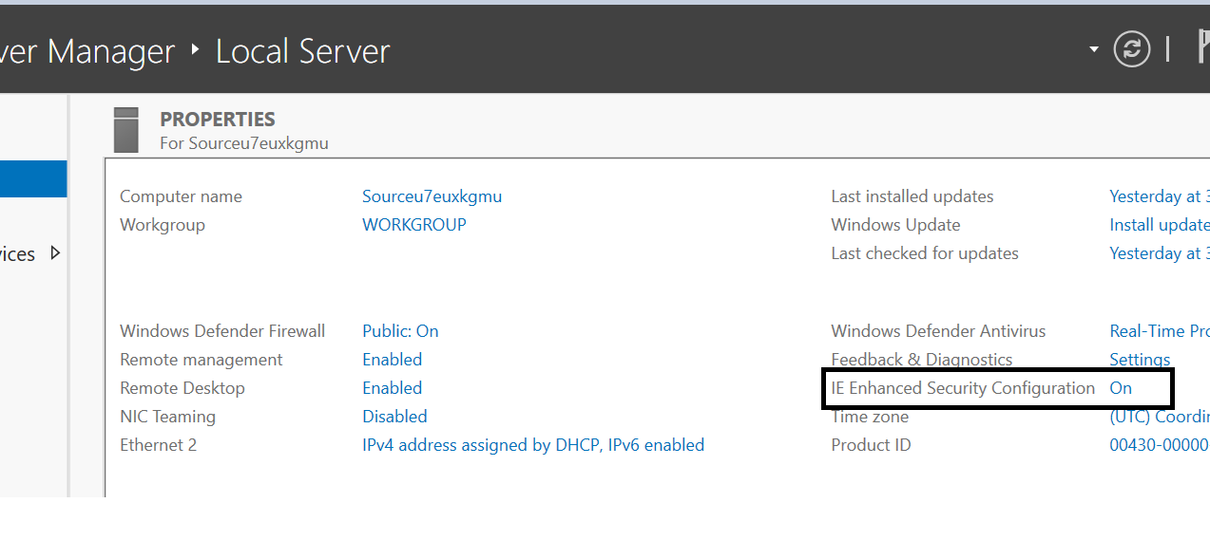

Choose **Off** in both options and click on save. (These steps help in seamless login to Azure subscription through Azure Data Studio).

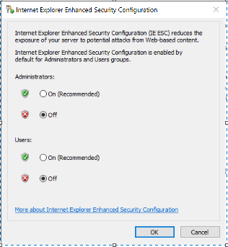

Search **Azure Data Studio** and Launch.

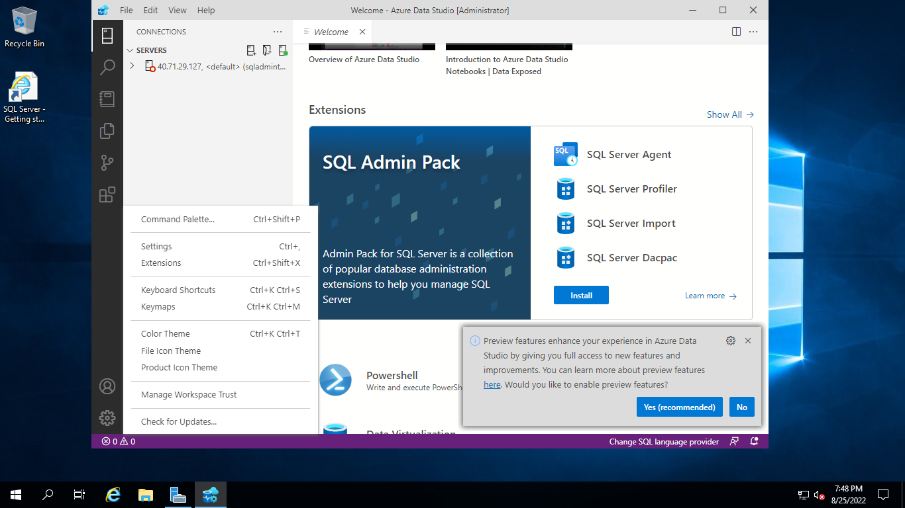

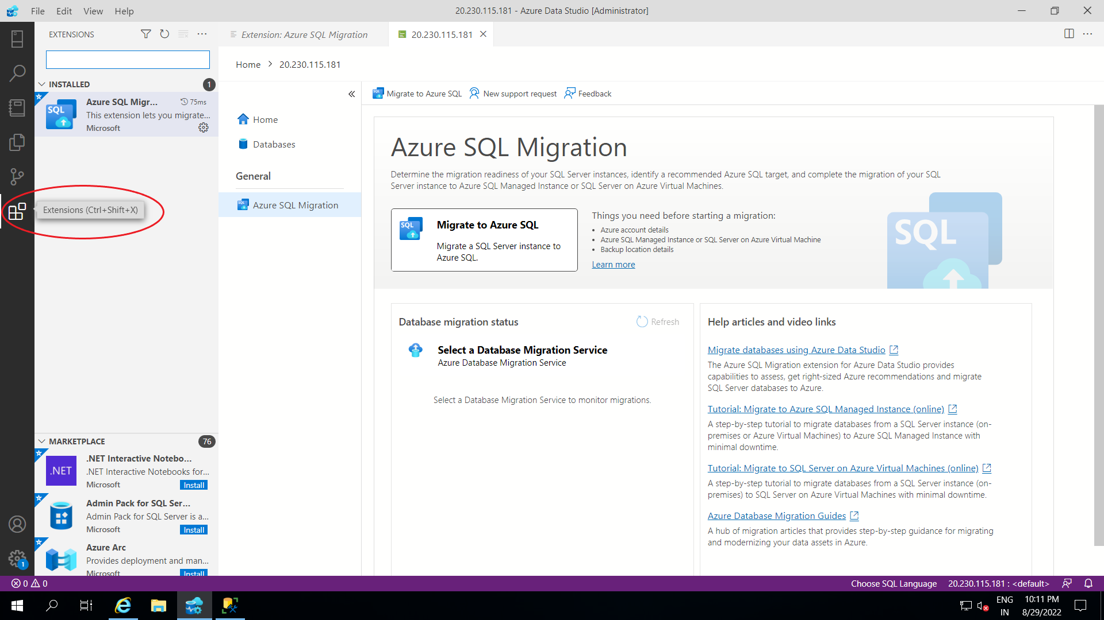Go to Extensions

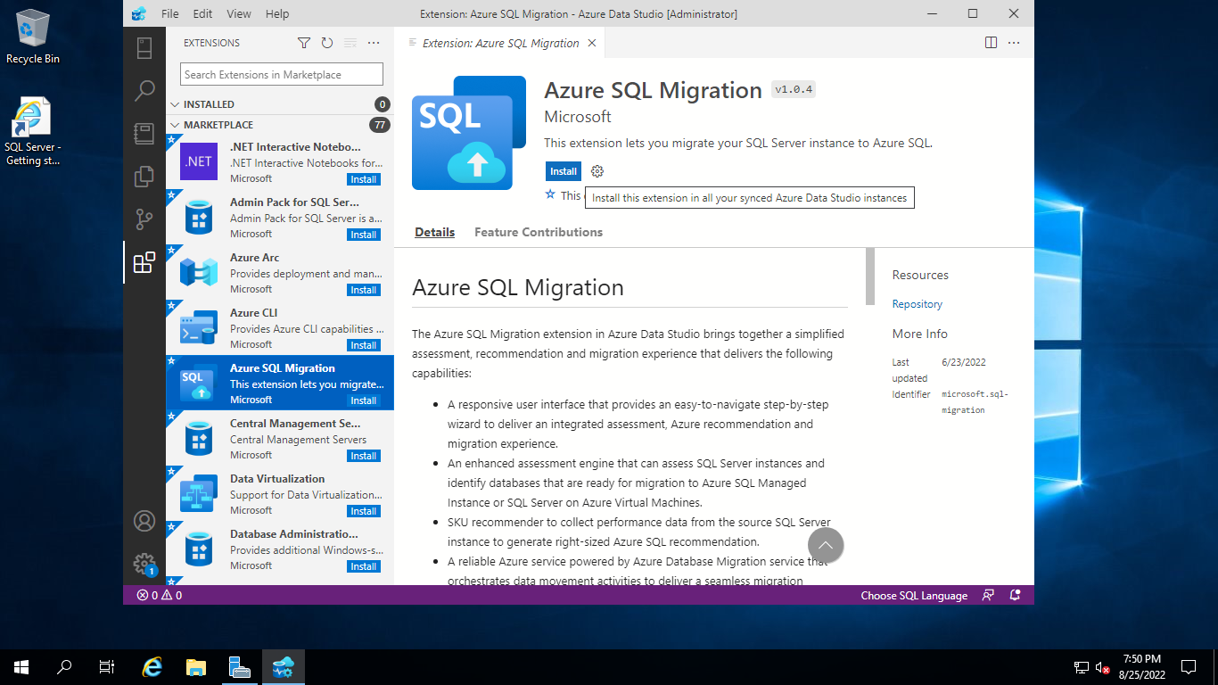

Search **Azure SQL Migration**

Extension and Install

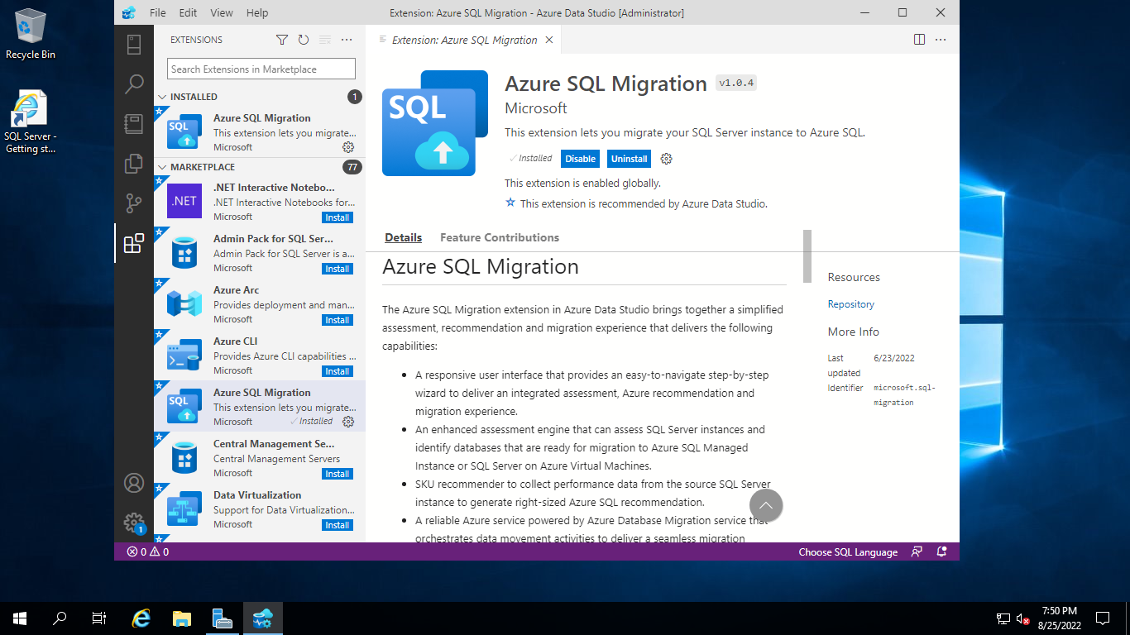

Then go to Command Palette

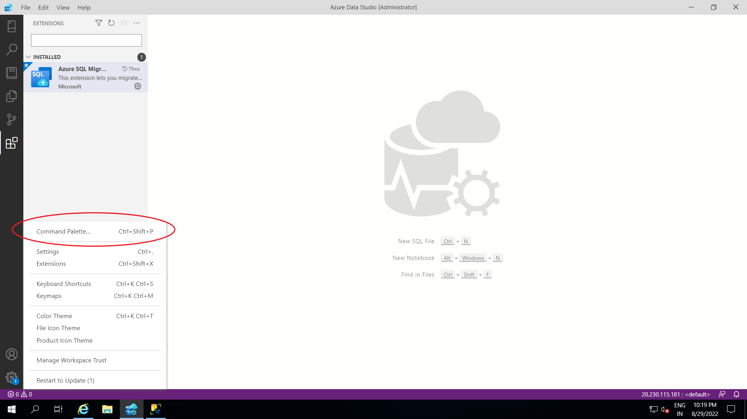

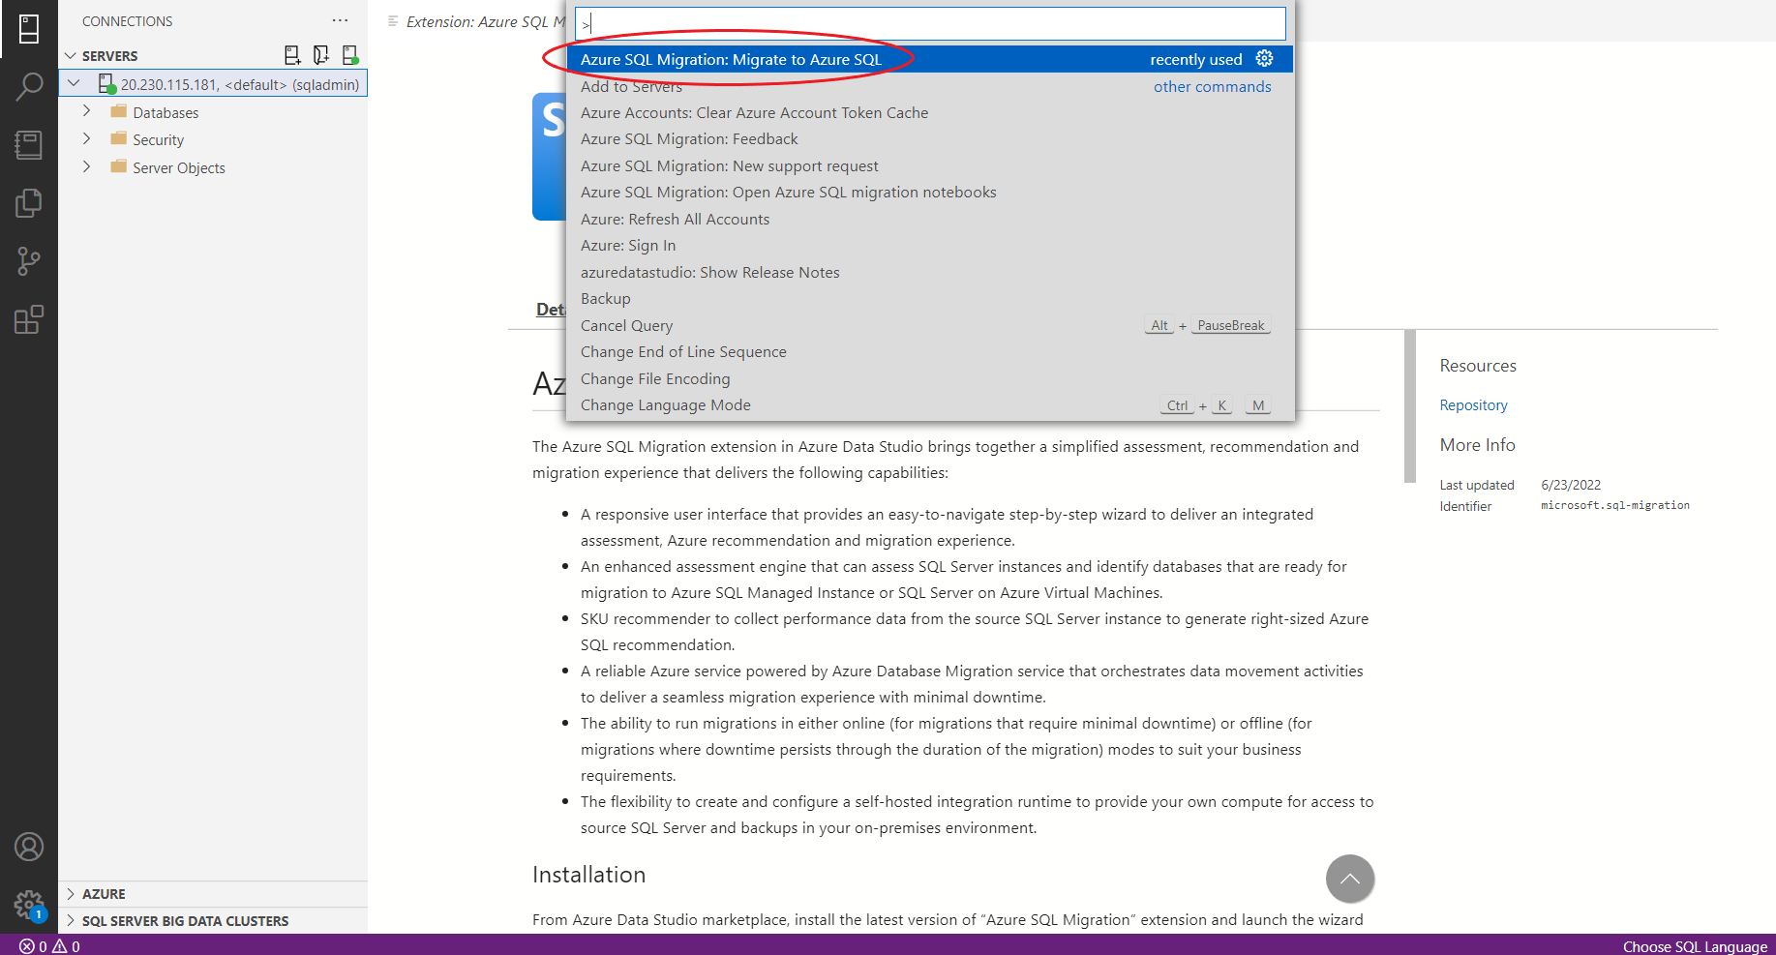

Type Azure SQL Migration: **Migrate to Azure SQL then Enter**

Provide Source Server **Public IP address**

Authentication Type: **SQL Login**

Provide SQL Username: **sqladmin** and Password: **Password@123**

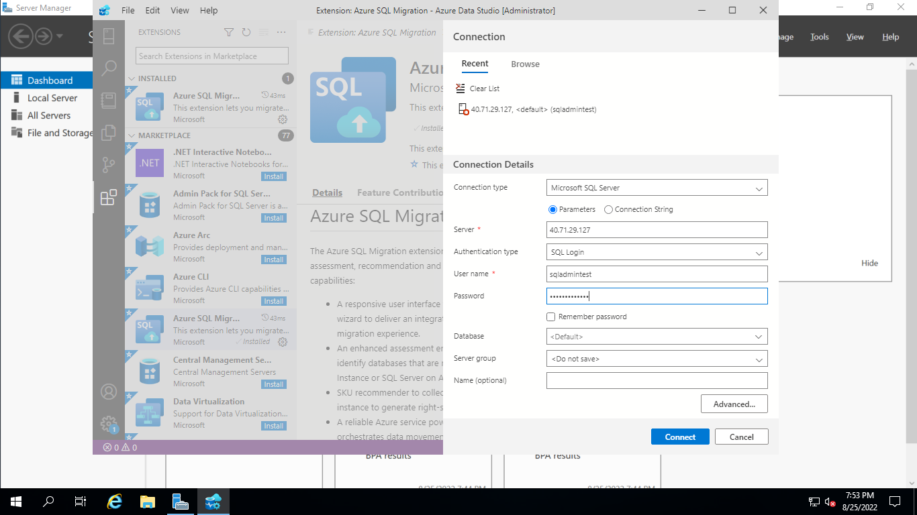

Select **Connect**

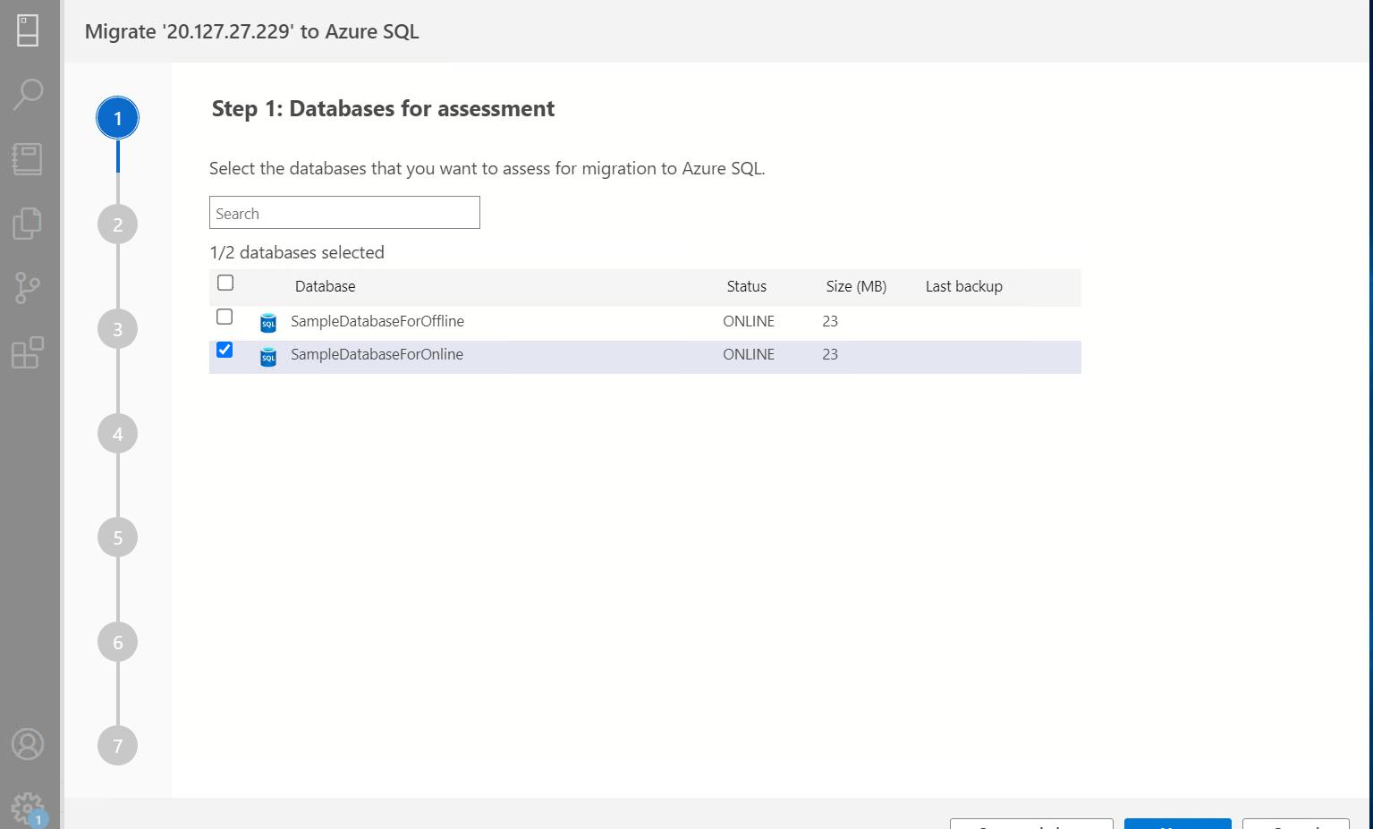

Select **SampleDatabaseForOnline**

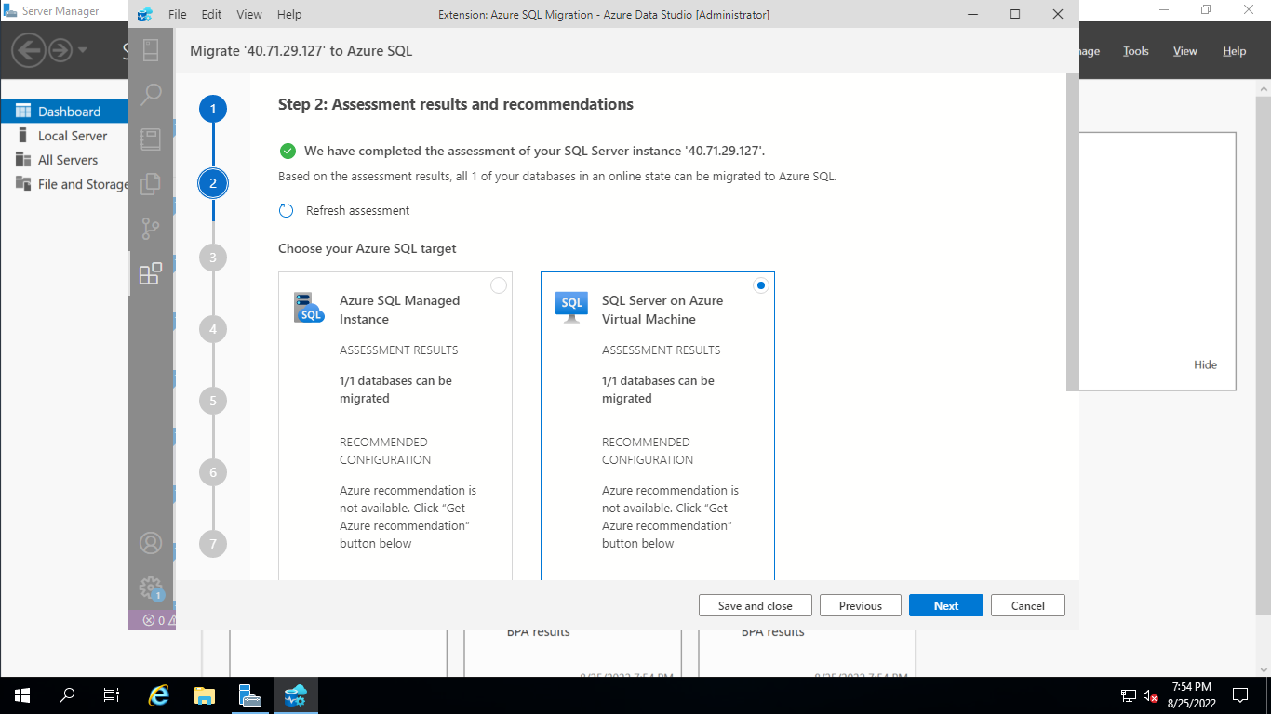

Select SQL Server on Azure Virtual Machine

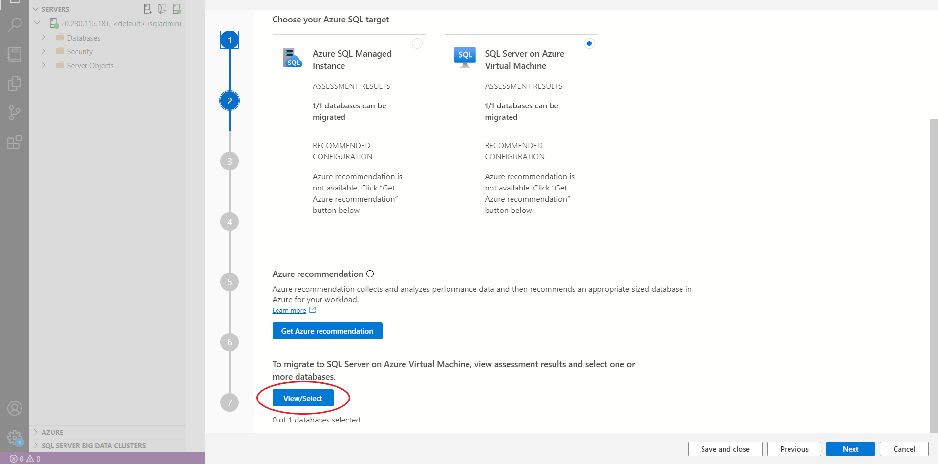

Then Select **View/Select**

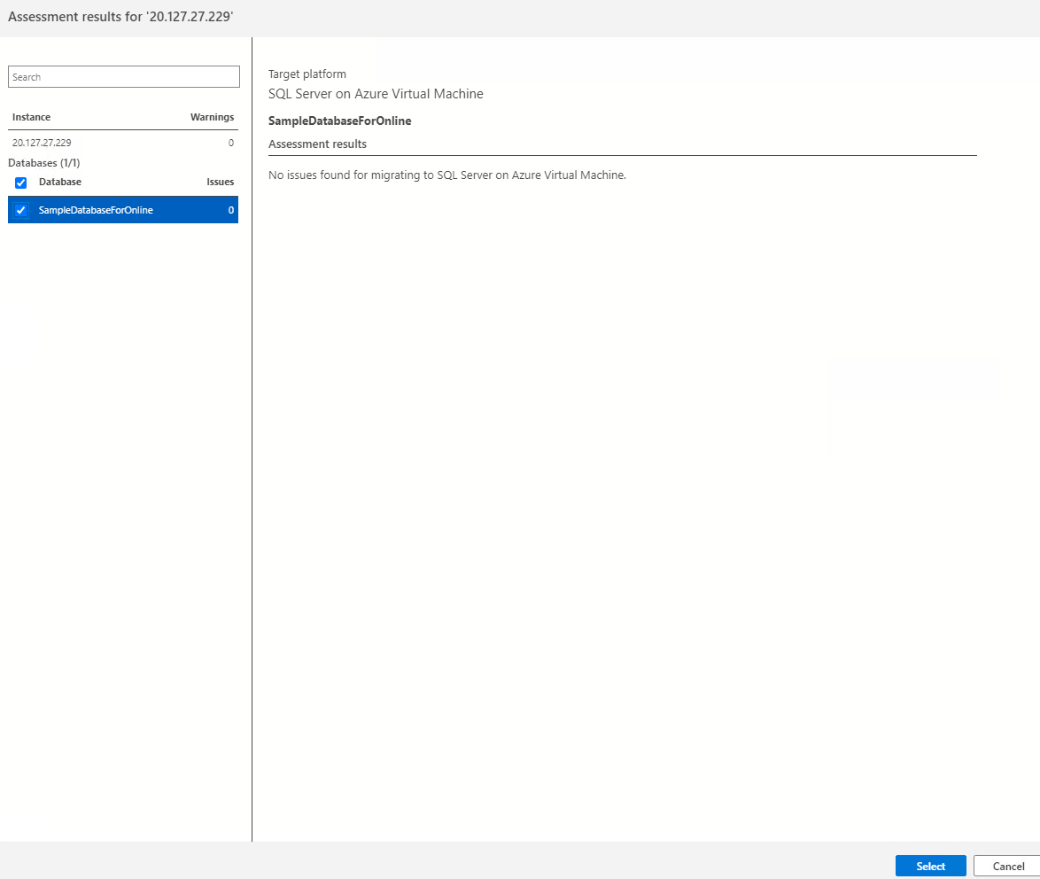

Select **SampleDatabaseforOnline**

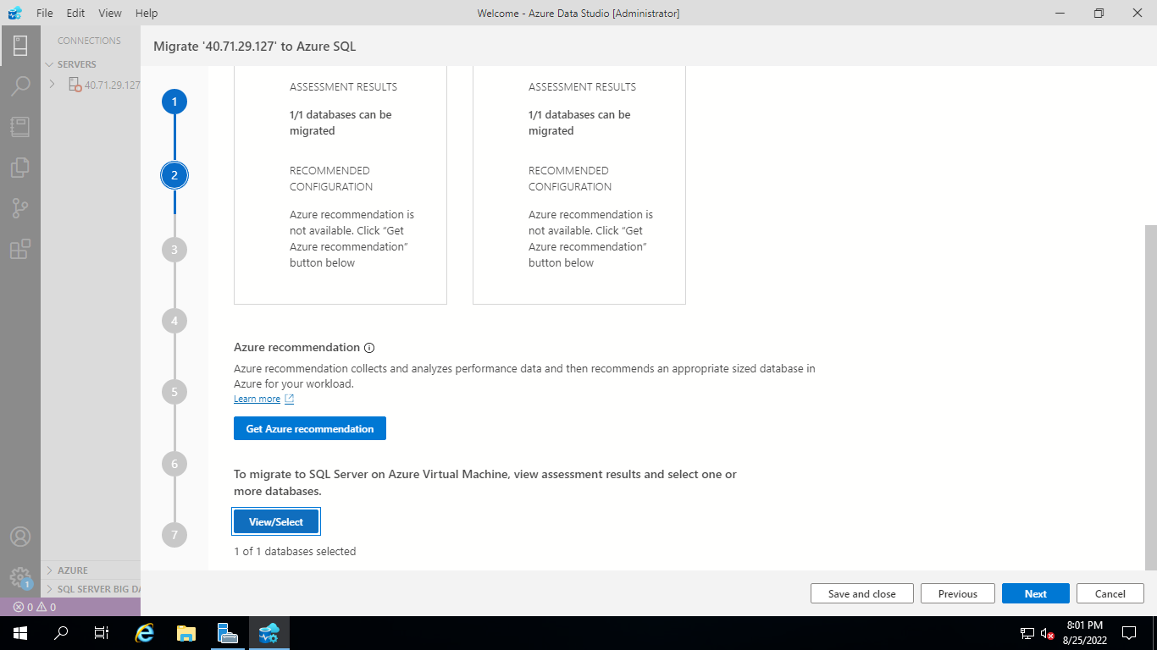

Click Next

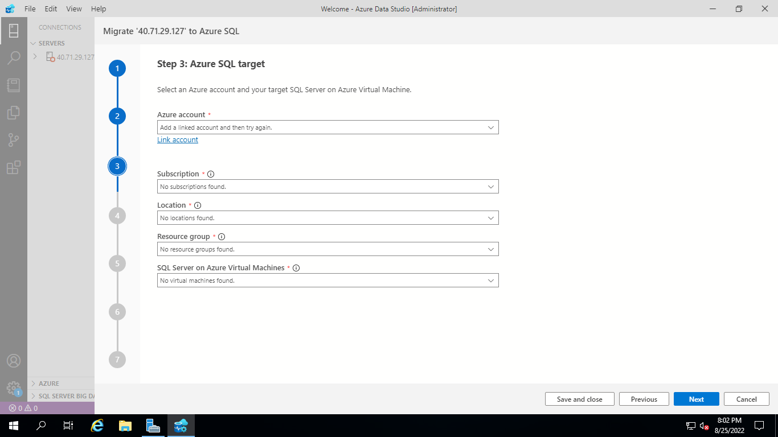

Provide Azure SQL Target fields

Azure Account: Link Account with Azure login details

**Subscription:**

**Location: East US**

**Resource Group: Target VM Resource Group**

**SQL Server on Azure Virtual machines: Target VM Name**

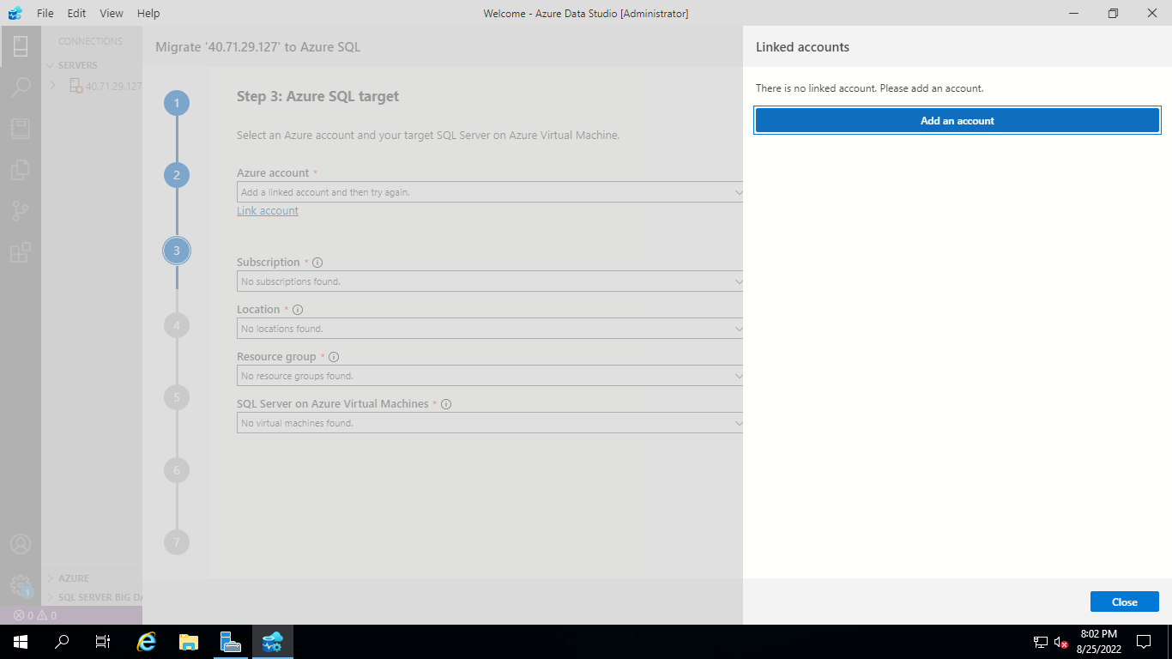

Click on Add an Account

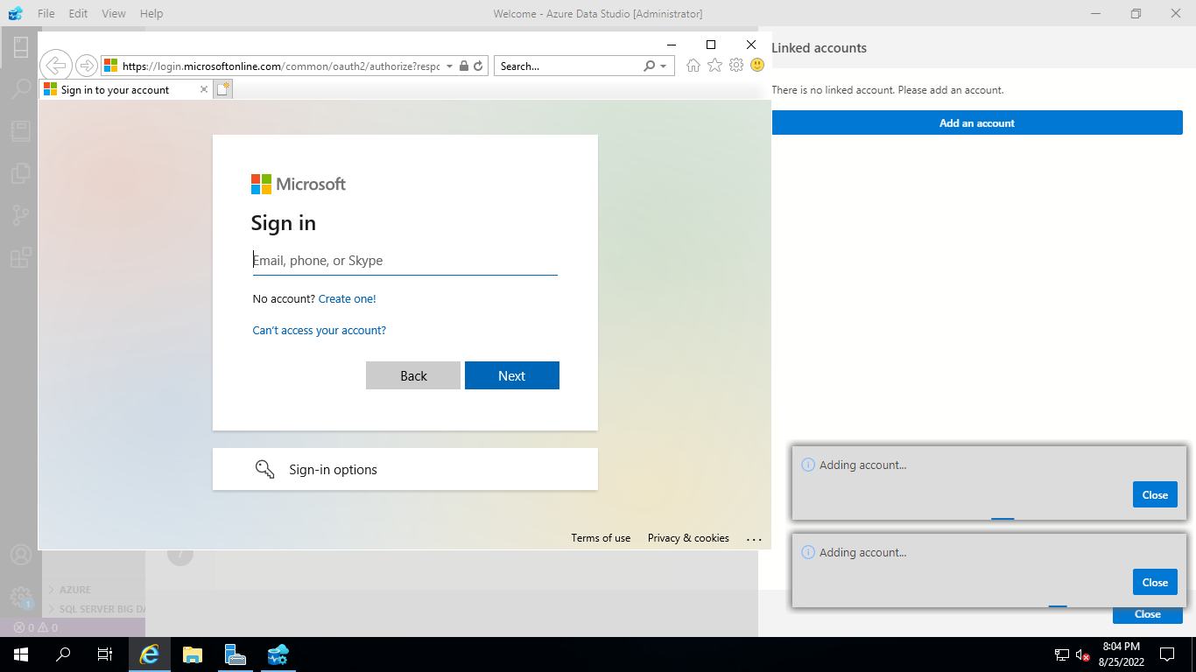

Provide Azure Portal Login Details

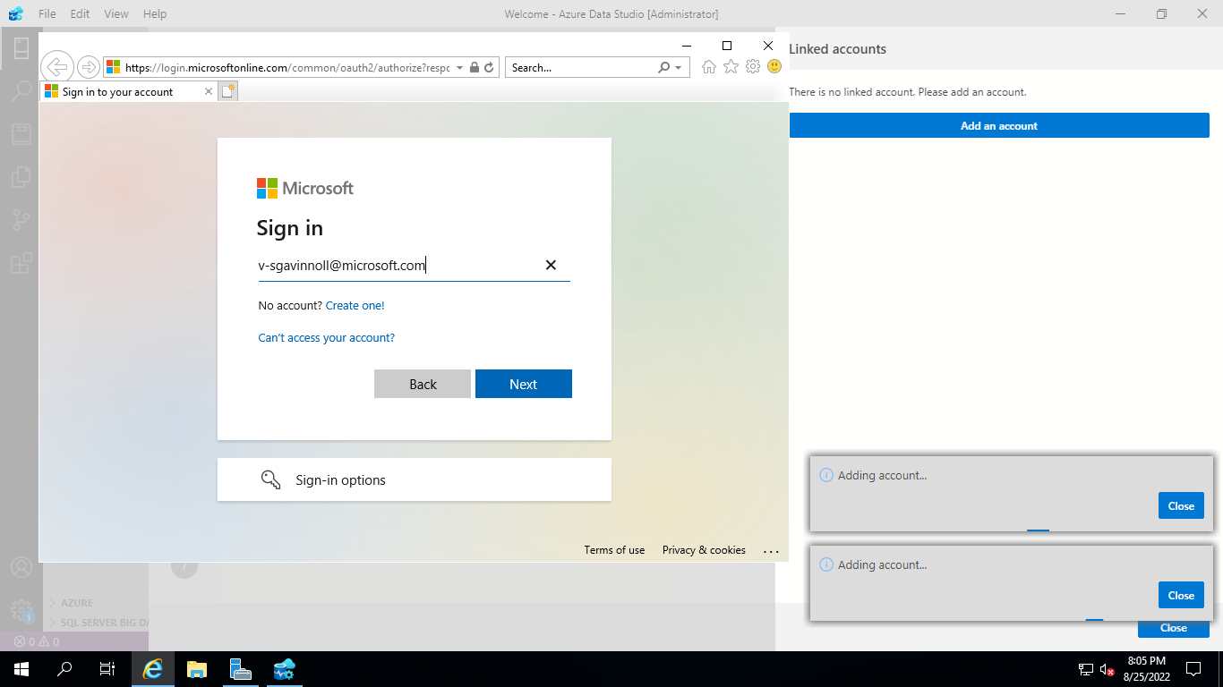

Close once you add your account

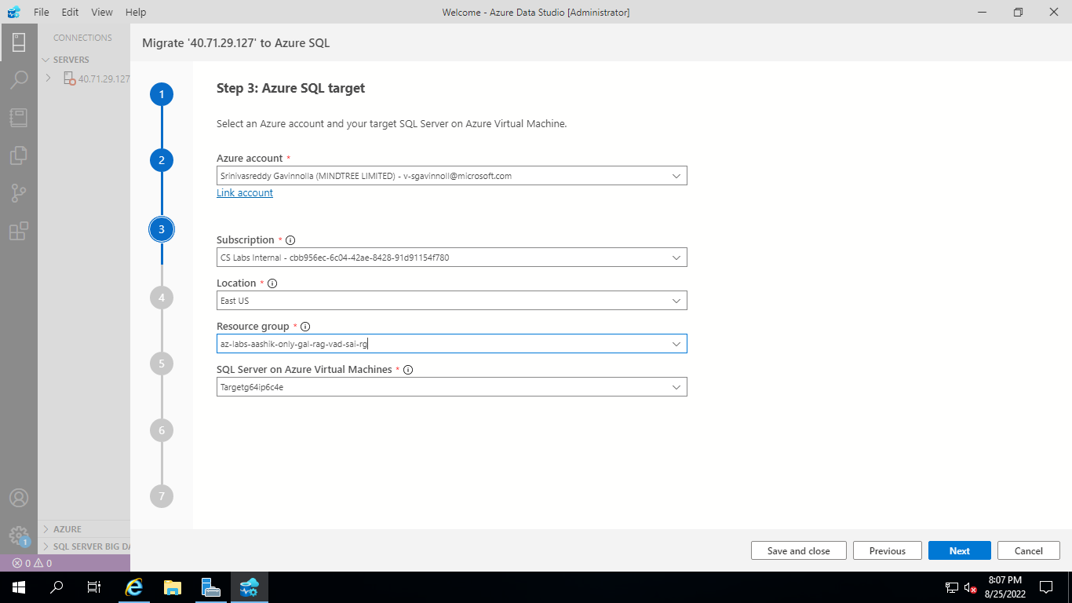

Select **Online migration**

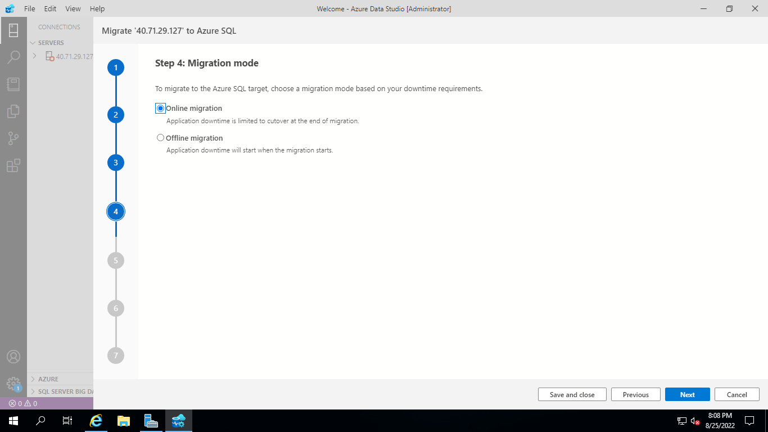

1. Select **Online migration** as the migration mode.
2. Select the location of database backups. Source database backup in an Azure storage blob container.
3. For backups stored in an Azure storage blob container specify the below details of the **Target database name**, **Resource group**, **Azure storage account**, **Blob container** and **Last backup file from** the corresponding drop-down lists.

| **Field** | **Description** |
| --- | --- |
| **Target database name** | The target database name can be modified if you wish to change the database name on the target during the migration process. |
| **Storage account details** | The resource group, storage account and container where backup files are located. |
| **Last Backup File** | The file name of the last backup of the database that you are migrating. |

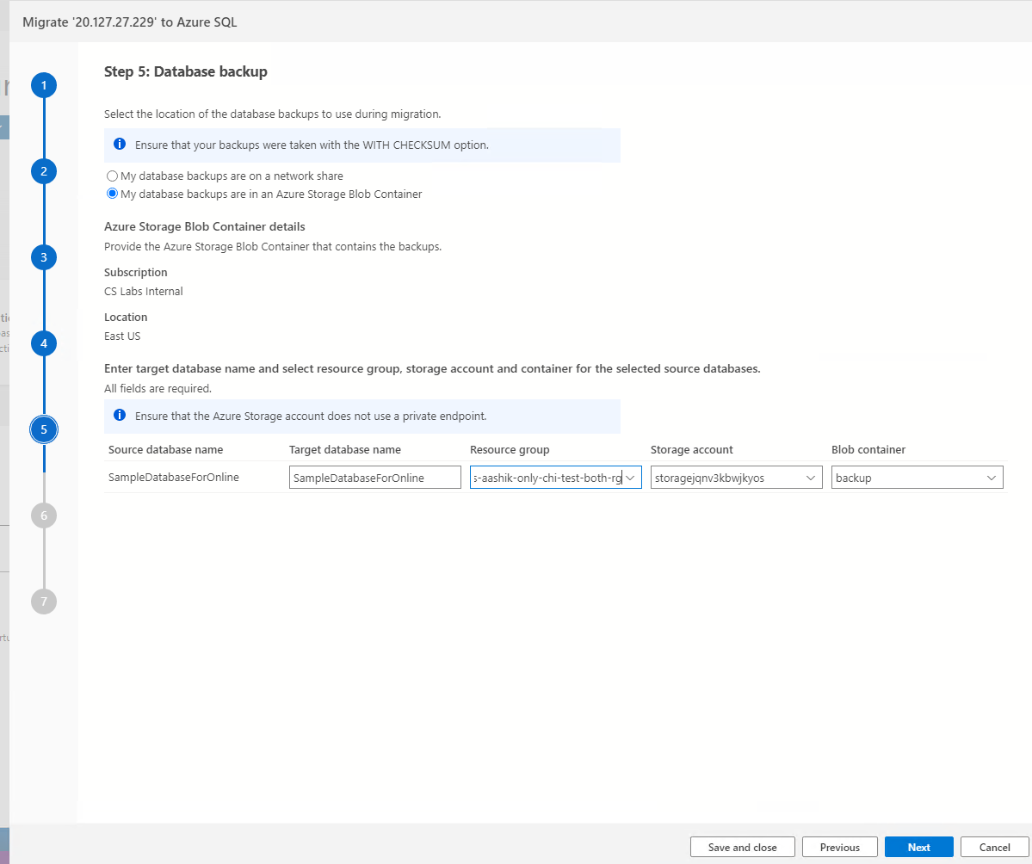

Provide Storage Account Blob Container details

Resource Group

Storage Account

Blob Container

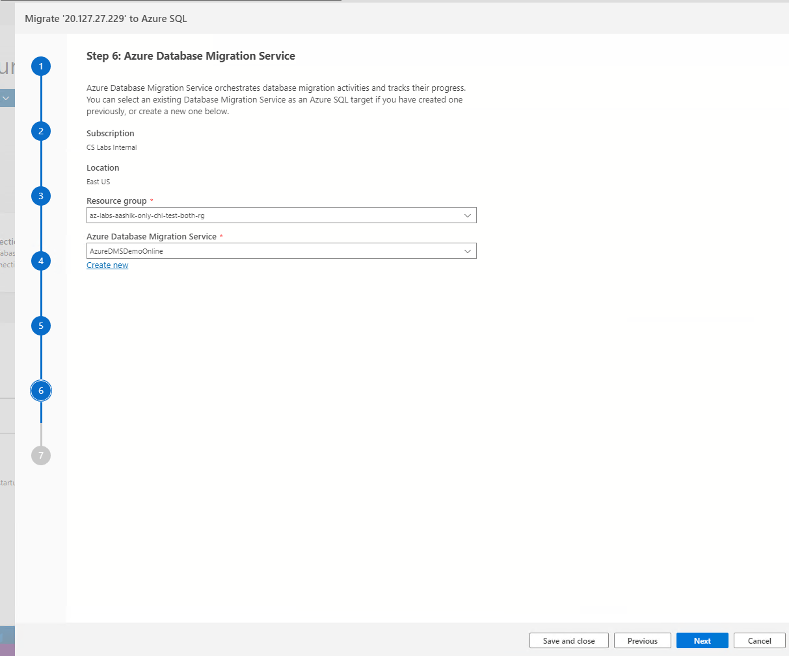

**Create Azure Database Migration Service**

1. Create a new Azure Database Migration Service or reuse an existing Service that you previously created.
2. Select the **Resource group** where you have an existing DMS or need to create a new one. The **Azure Database Migration Service** dropdown will list any existing DMS in the selected resource group.
3. To create a new DMS, select on **Create new**.
4. On the **Create Azure Database Migration Service**, screen provide the name for your DMS and select **Create**.

Note: Please Provide the name of new DMS as ‘**onlinedms**’

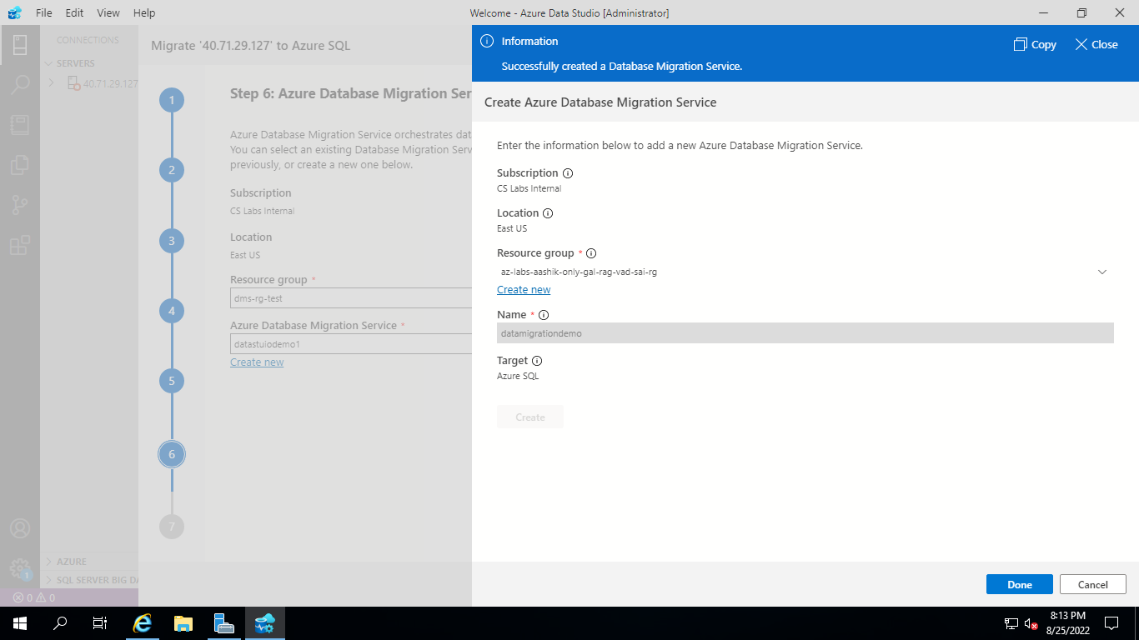

Click Done once you create a Data Migration Service



Click Next

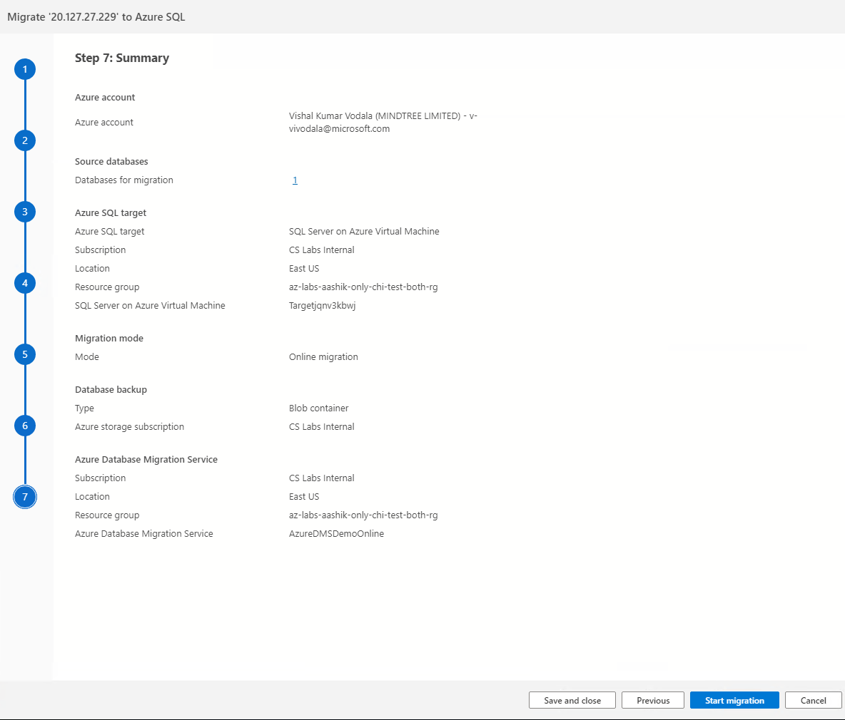

Select **Start migration**.

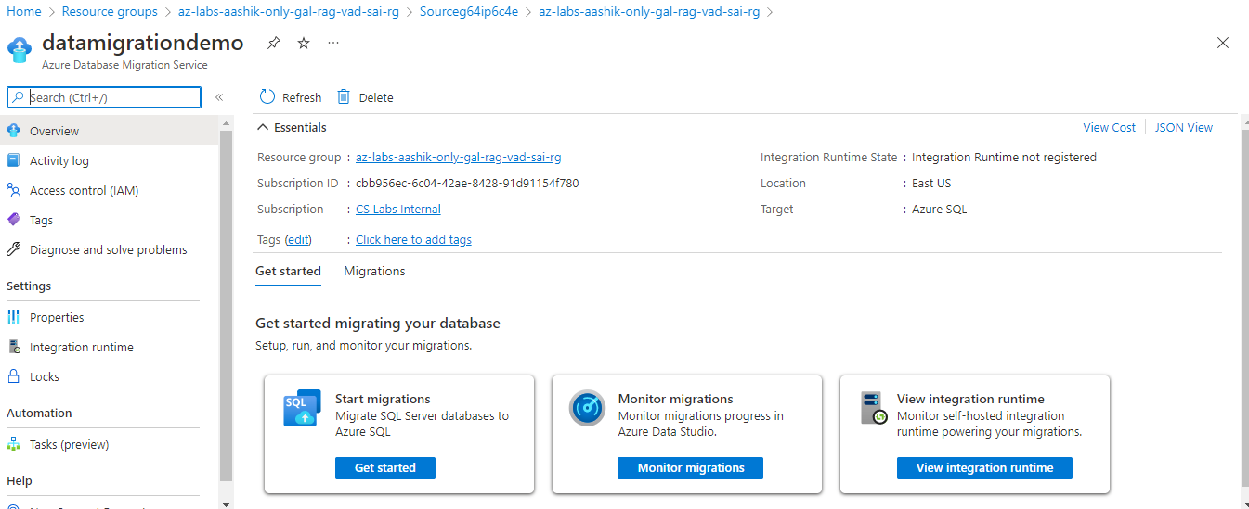

**Monitor the migration**

**Open newly created ‘onlinedms’ and select Monitor migrations**

On the migration activity screen, select **Refresh** to update the display until the **Status** of the migration shows as **Completed**.

**Monitor your migration**

1. On the **Database Migration Status**, you can track the migrations in progress, migrations completed

After all database backups are restored on SQL Server on Azure Virtual Machine, Complete cutover button will be enabled inside the specific Azure DMS to ensure the migrated database is ready for use. Please select Complete Cutover button.

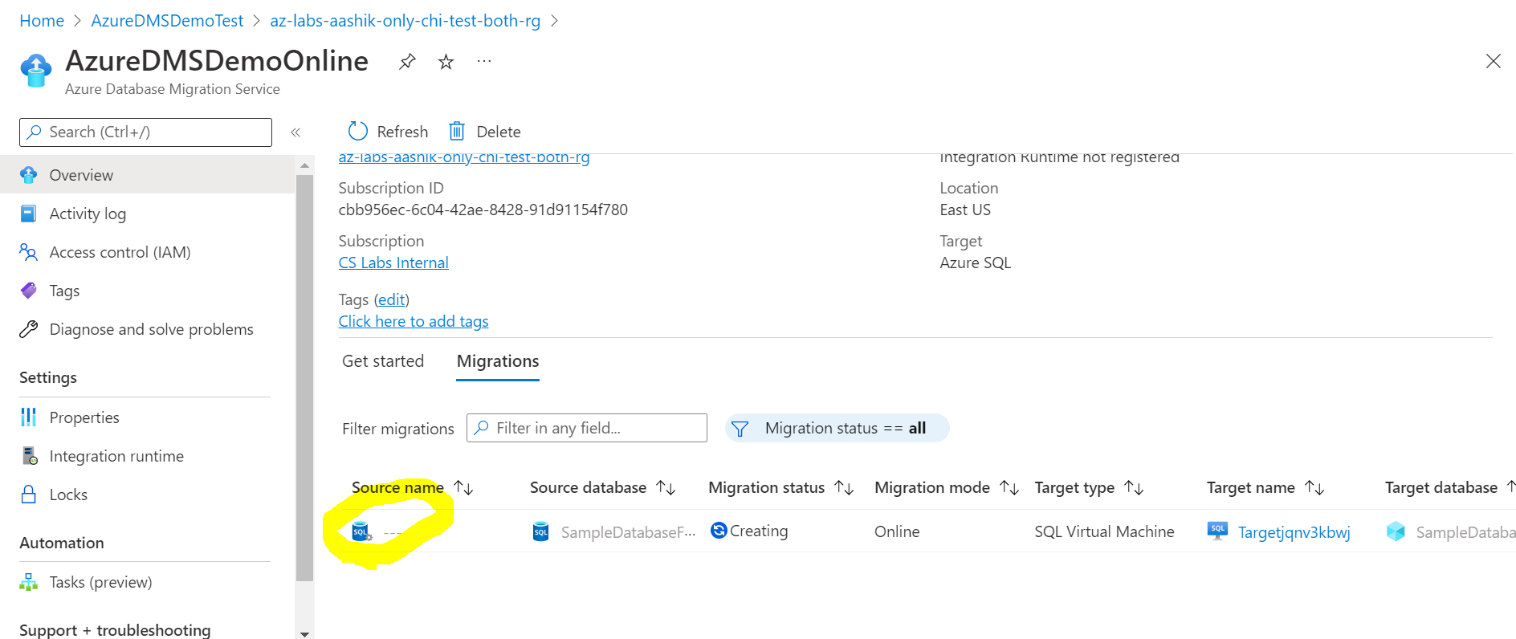

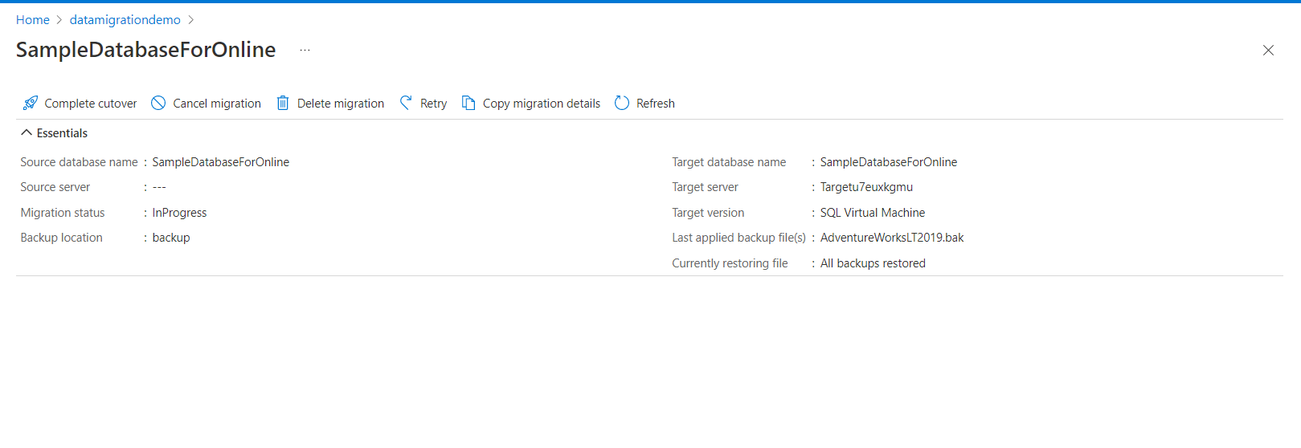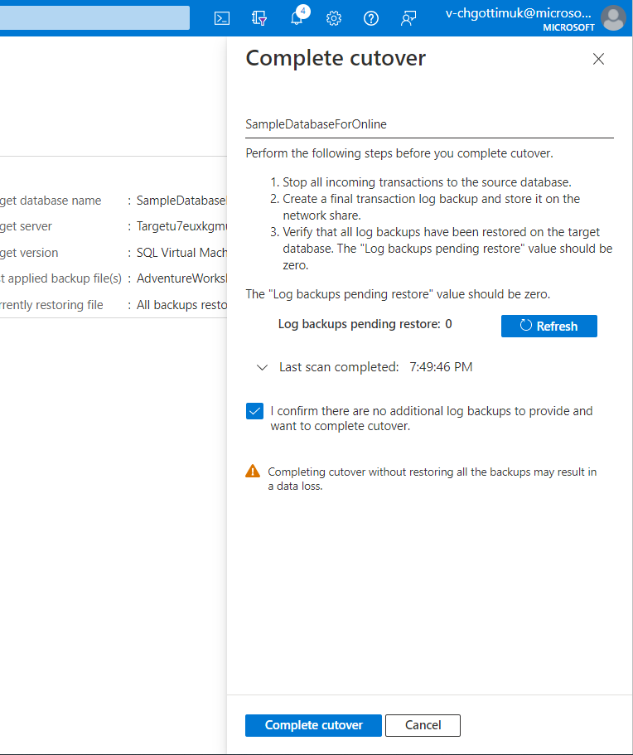

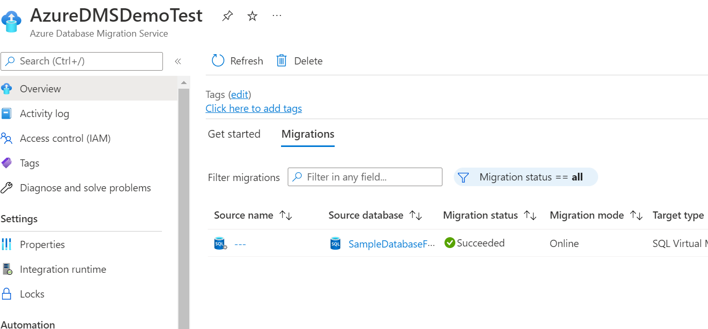

**Post Migration Validation Steps**

1. Login to target VM using RDP

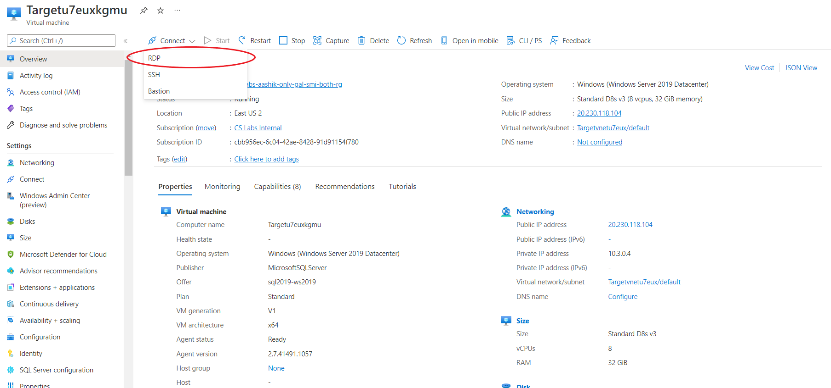

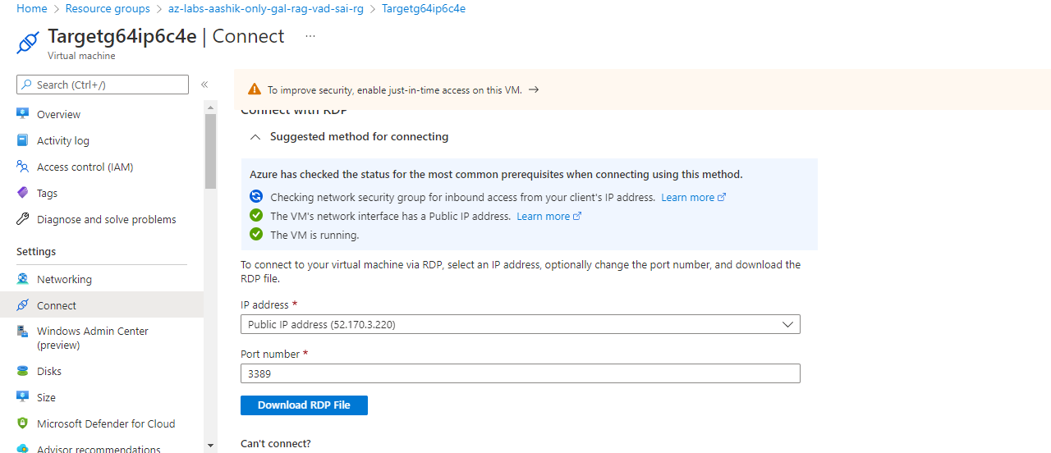

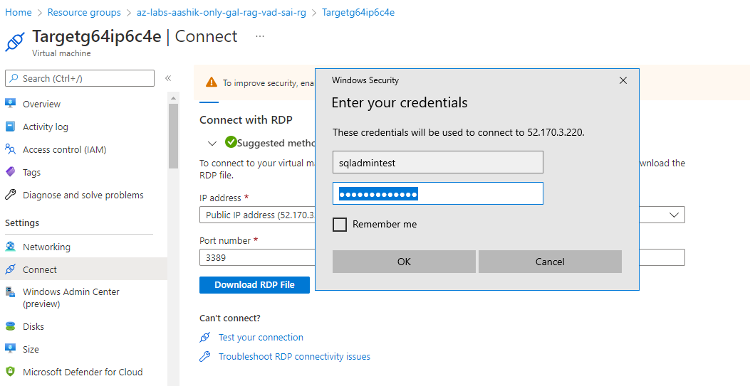

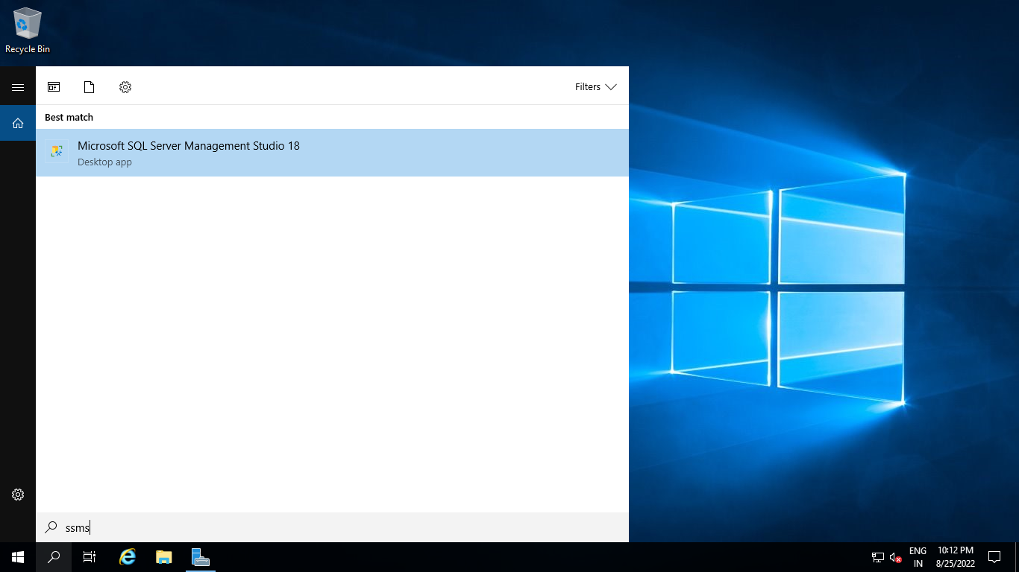

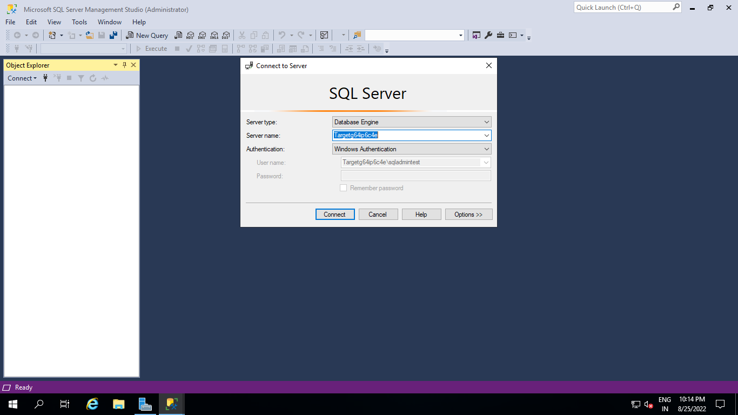

1. **Execute below SQL Query:**

Query:

select schema_name(tab.schema_id) + '.' + tab.name as [table],

sum(part.rows) as [rows] from sys.tables tab

inner join sys.partitions part on tab.object_id = part.object_id

where part.index_id IN (1, 0)

group by schema_name(tab.schema_id) + '.' + tab.name

order by sum(part.rows) desc

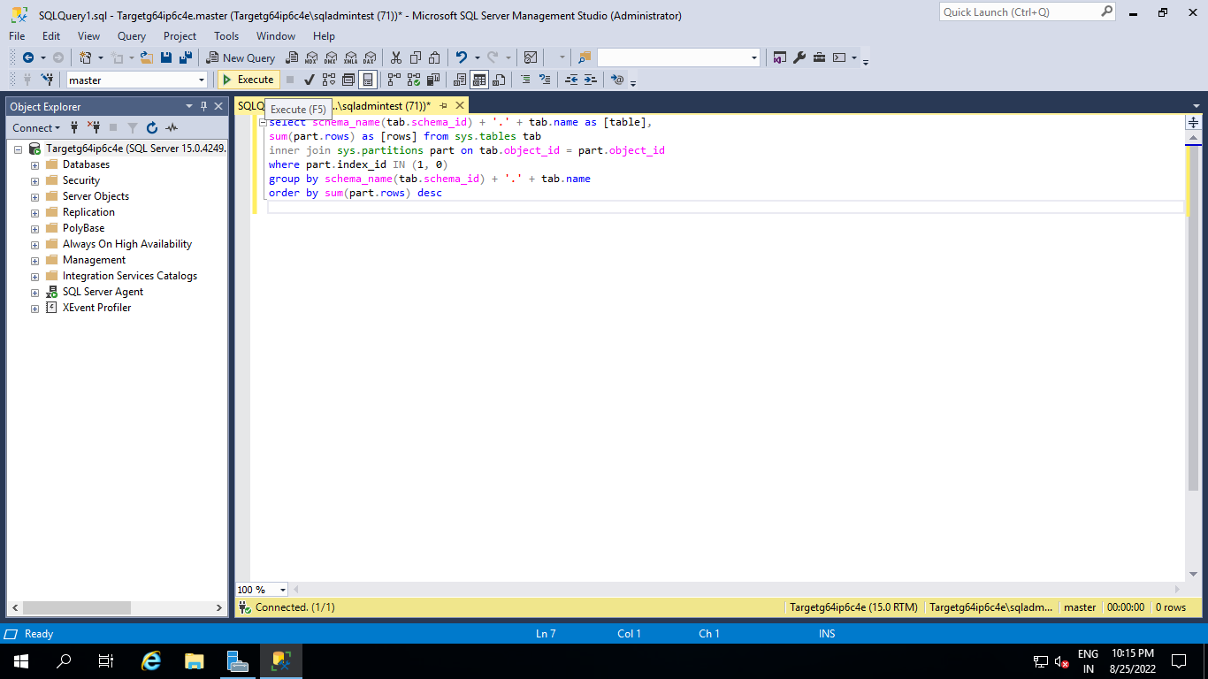

Please validate output with below parameters.

**Output:**

table, rows

SalesLT.Customer,847

SalesLT.ProductDescription,762

SalesLT.ProductModelProductDescription,762

SalesLT.SalesOrderDetail,542

SalesLT.Address,450

SalesLT.CustomerAddress,417

SalesLT.Product,295

SalesLT.ProductModel,128

SalesLT.ProductCategory,41

SalesLT.SalesOrderHeader,32

dbo. BuildVersion,1

dbo.ErrorLog,0

**Offline Migration:**



**Select Download RDP**

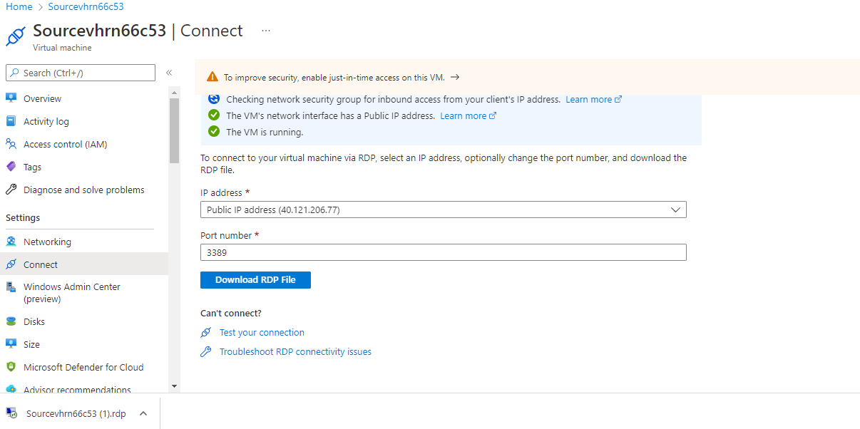

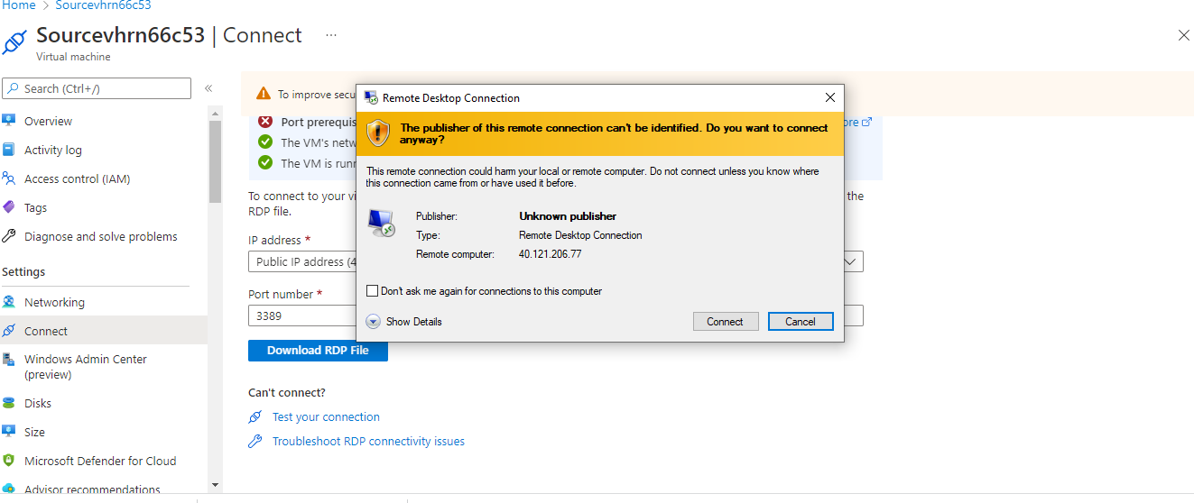

**Login to Source VM.**

Provide **SQL Username**: sqladmin and **Password: Password@123**

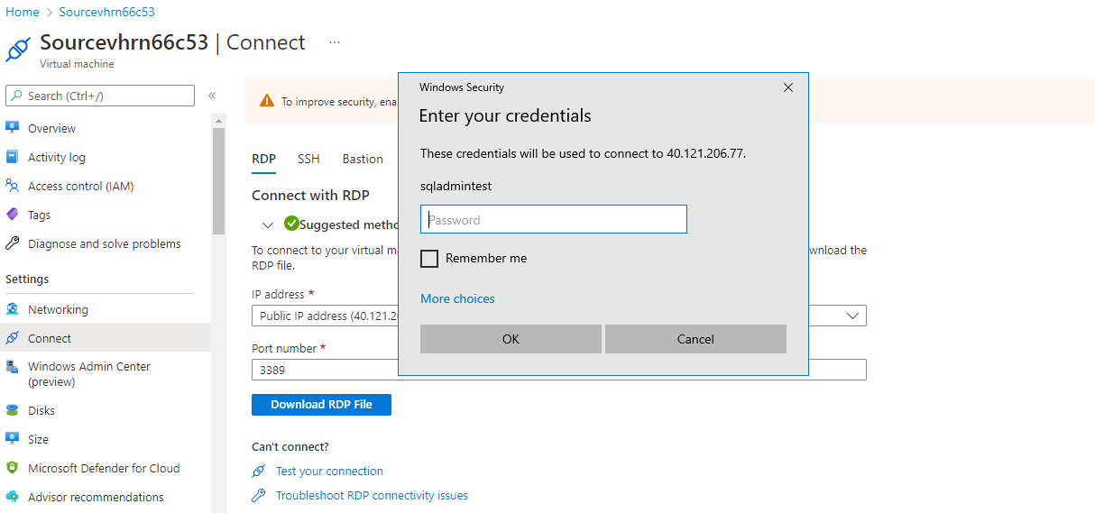

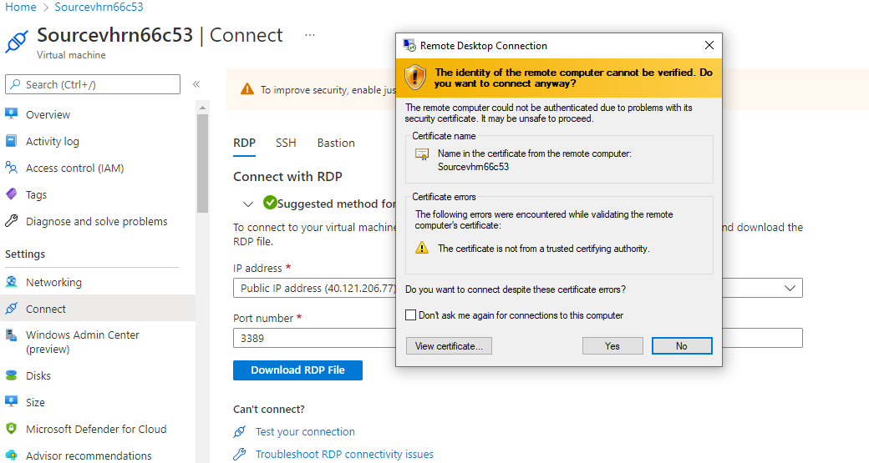

**After Login to SQL Source VM disable IE Enhanced Security Configuration**

Search for Server Manager, Go to Dashboard and choose Configure this local server.

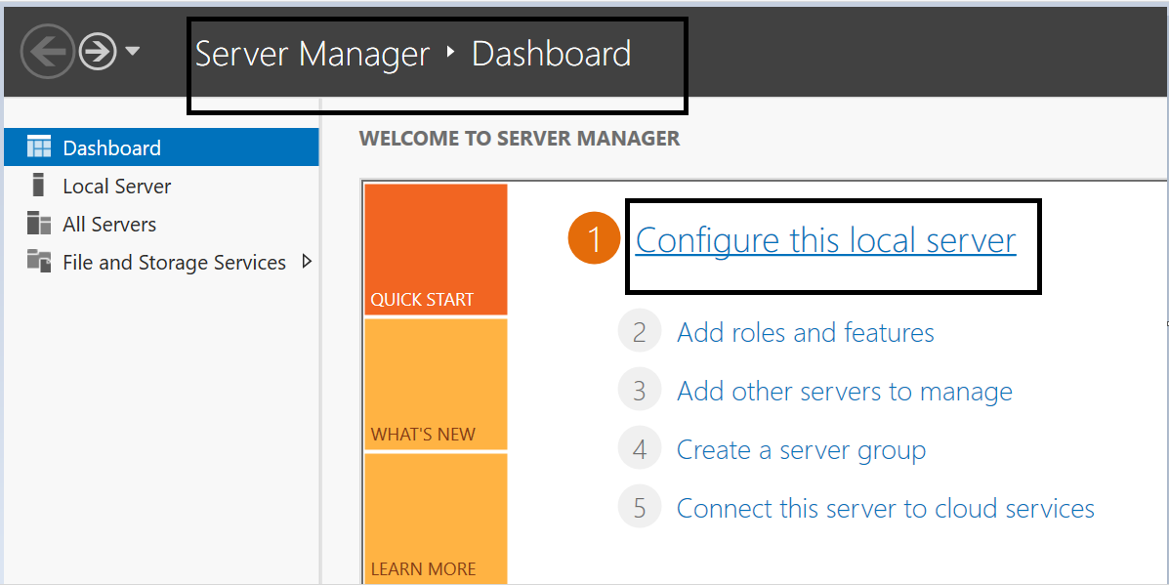

In properties pane navigate to IE enhanced security configuration and click on **On**.

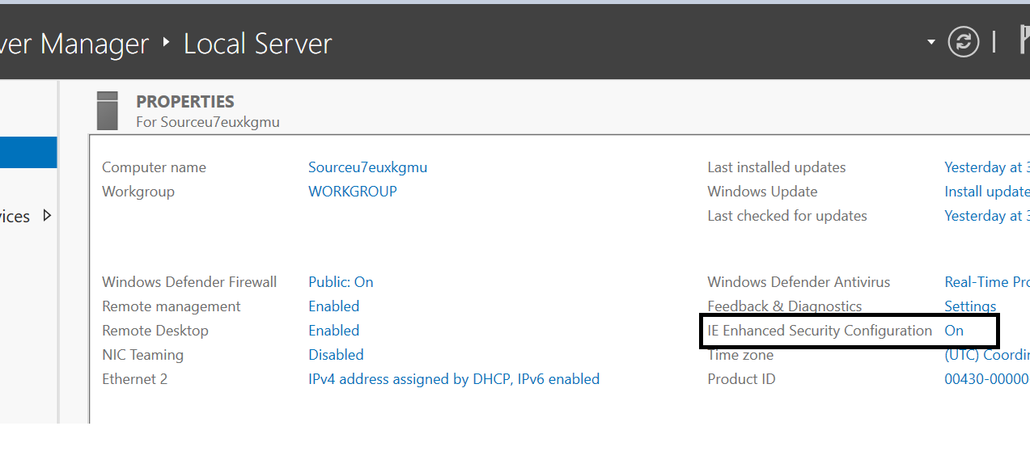

Choose **Off** in both options and click on save. (These steps helps in seamless login to azure subscription through Azure data studios).

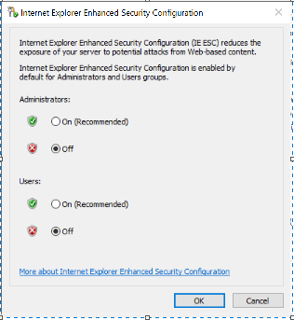

**After Login to SQL Source VM search Azure Data Studio and Launch.**



**Go to Extensions**

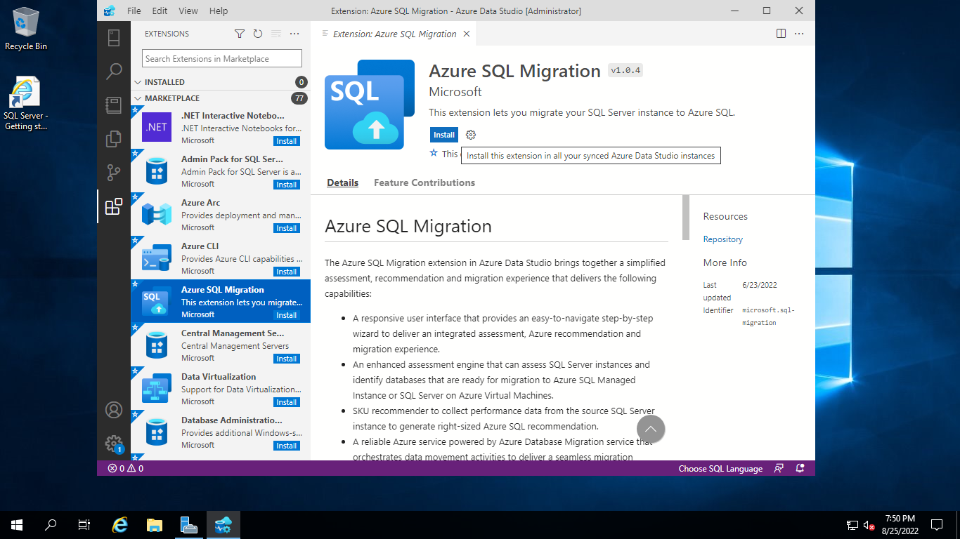

Search for **Azure SQL Migration** Extension and Install

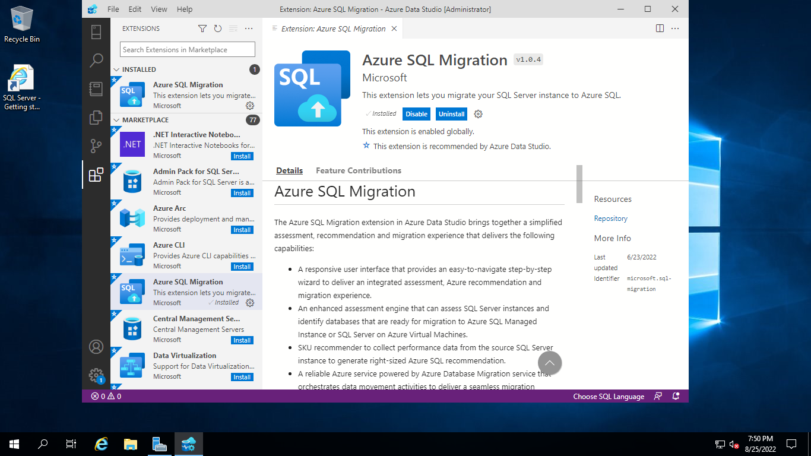

**Then go to Command Palette**





Search for **Azure SQL Migration: Migrate to Azure SQL** and select.

Provide Source Server Public IP address

Authentication Type: SQL Login

Provide SQL Username: sqladmin and Password: Password@123

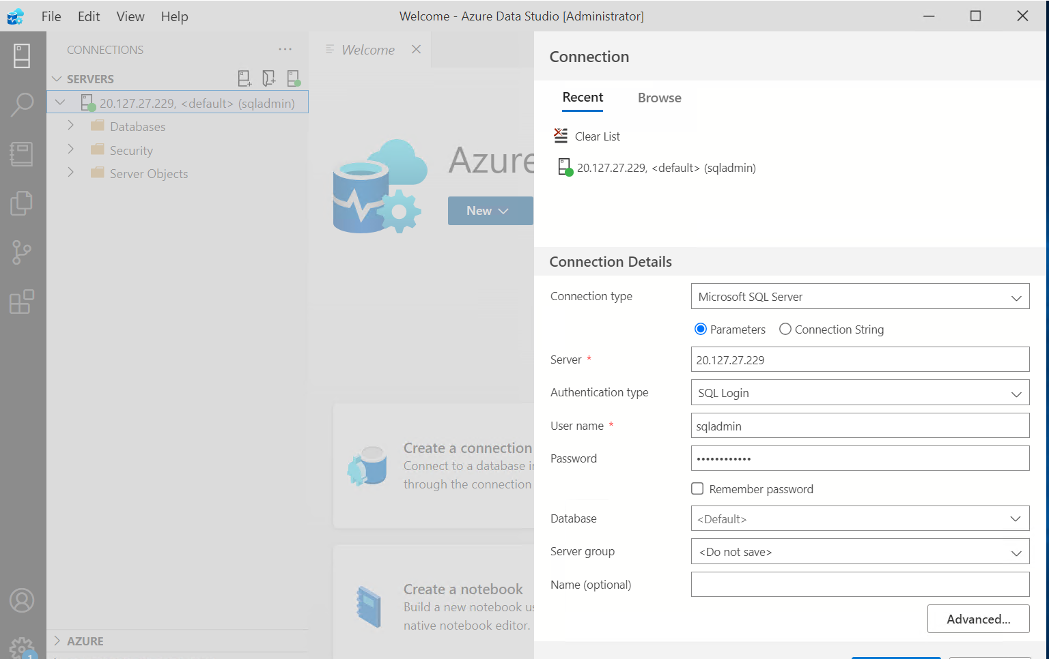

Select **Connect**

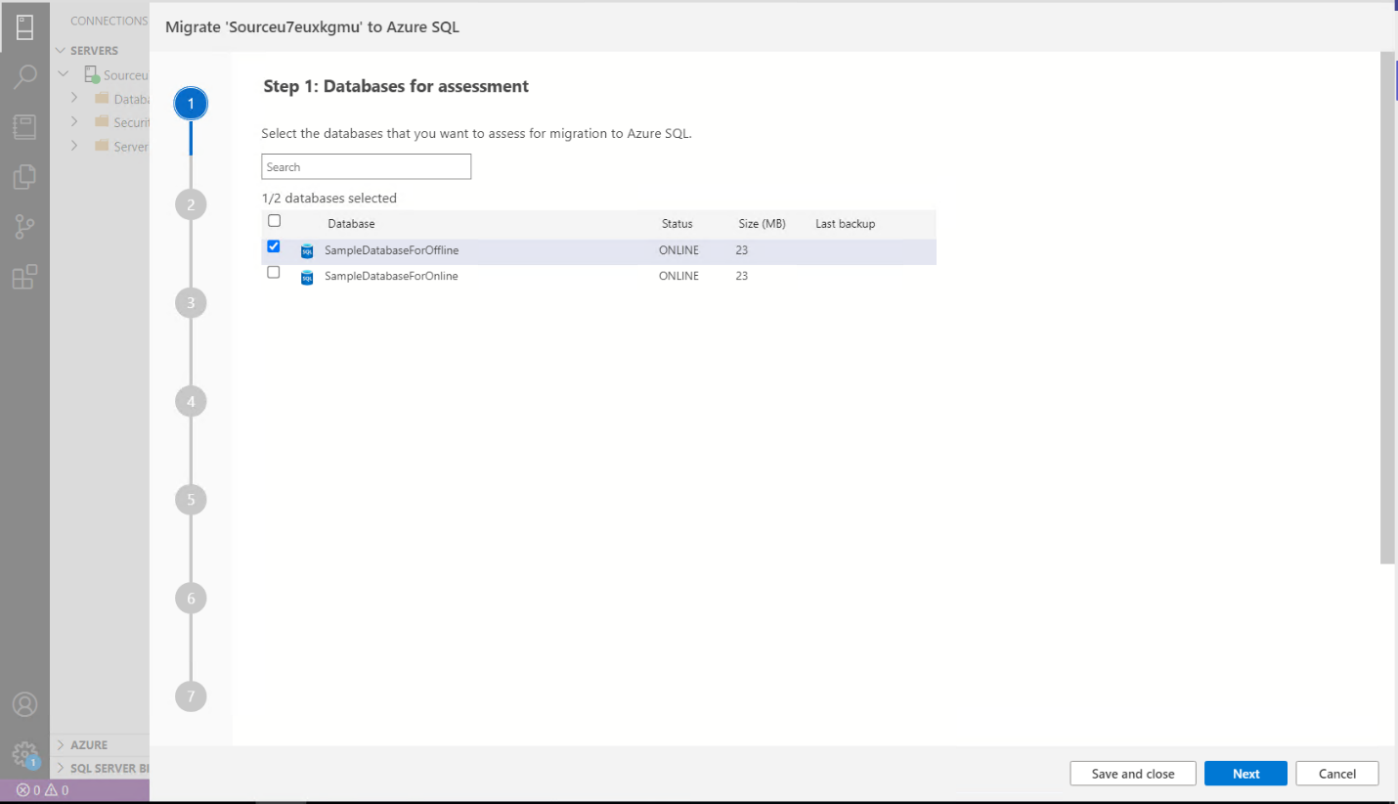  
Select **SampleDatabaseForOffline**

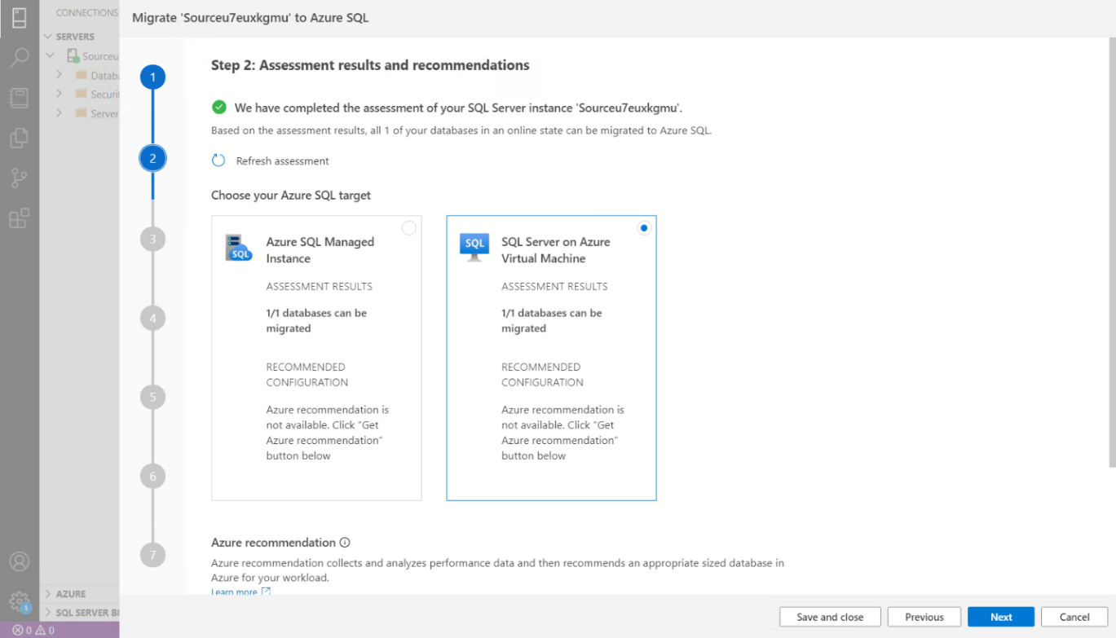

**Select SQL Server on Azure Virtual Machine**



Then Select **View/Select**   
  
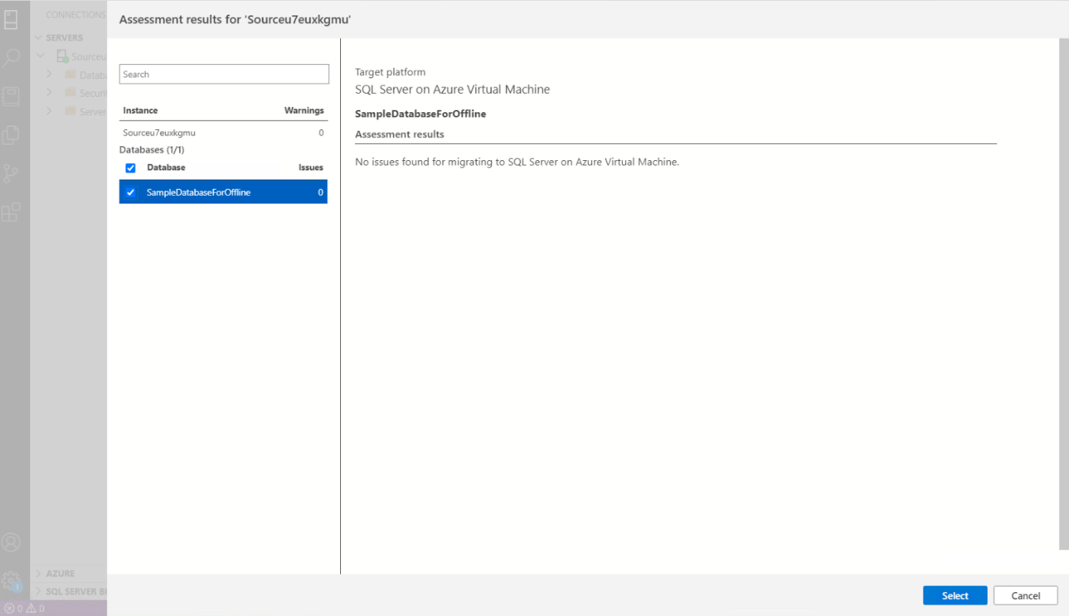

Choose SampleDatabaseforOffline and click on select

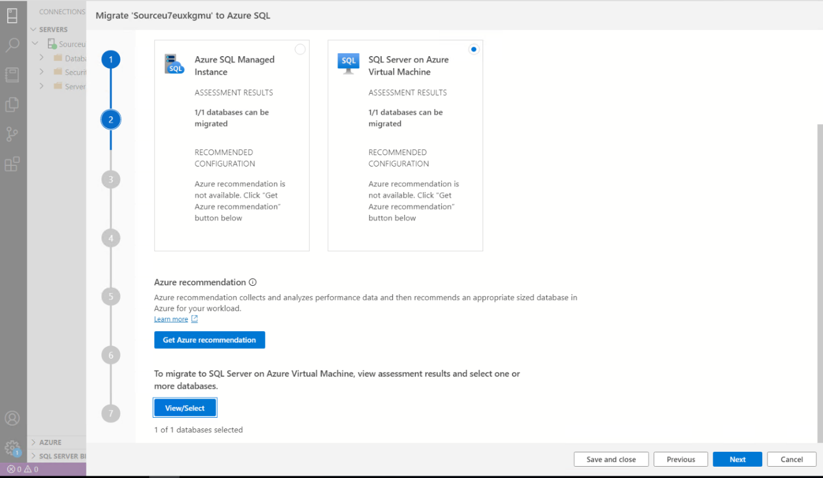

Click Next

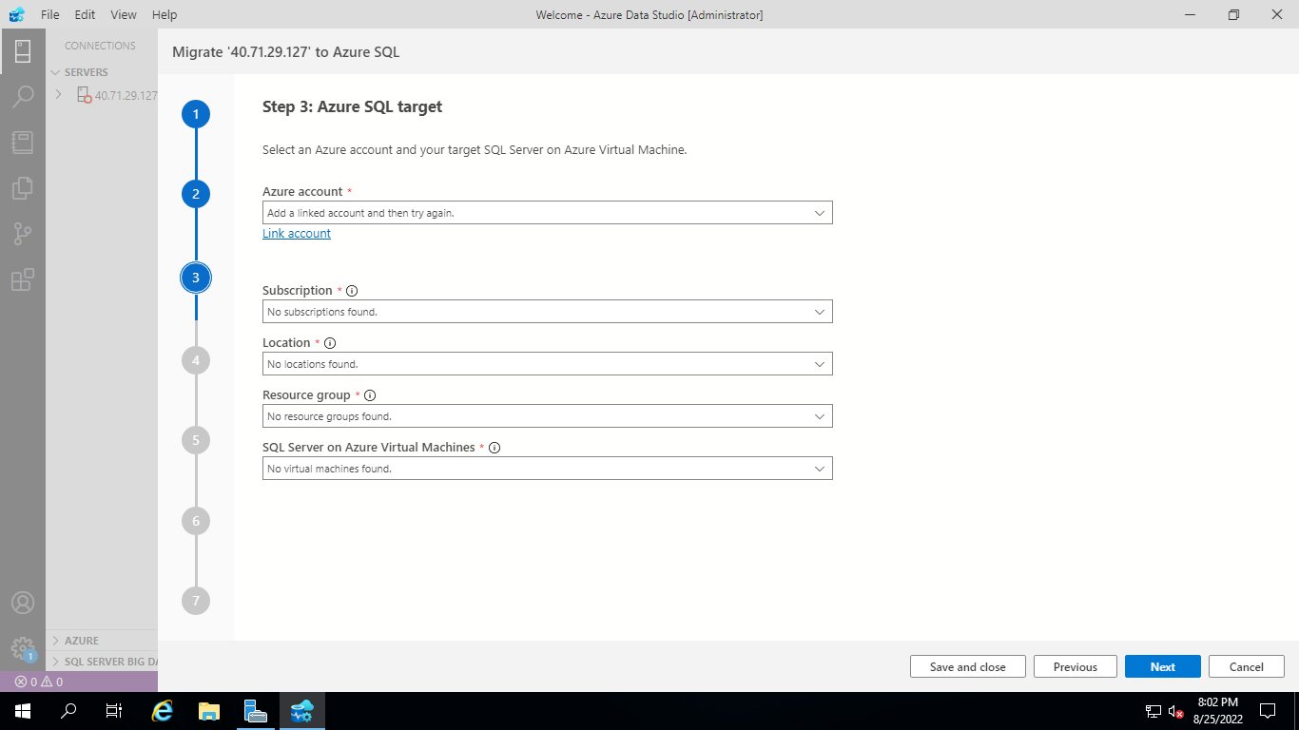  
Provide Azure SQL Target fields

**Azure Account:** Link Account with Azure login details

**Subscription:**

**Location:** East US

**Resource Group:** Target VM Resource Group

**SQL Server on Azure Virtual machines: Target VM Name**

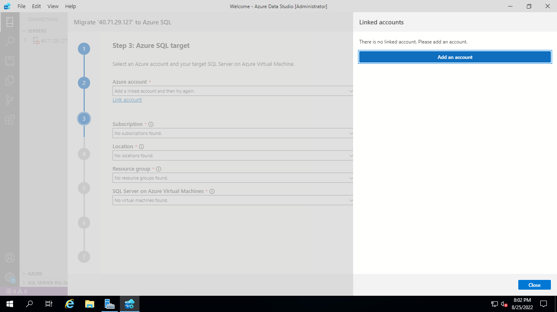

Click on Add an Account

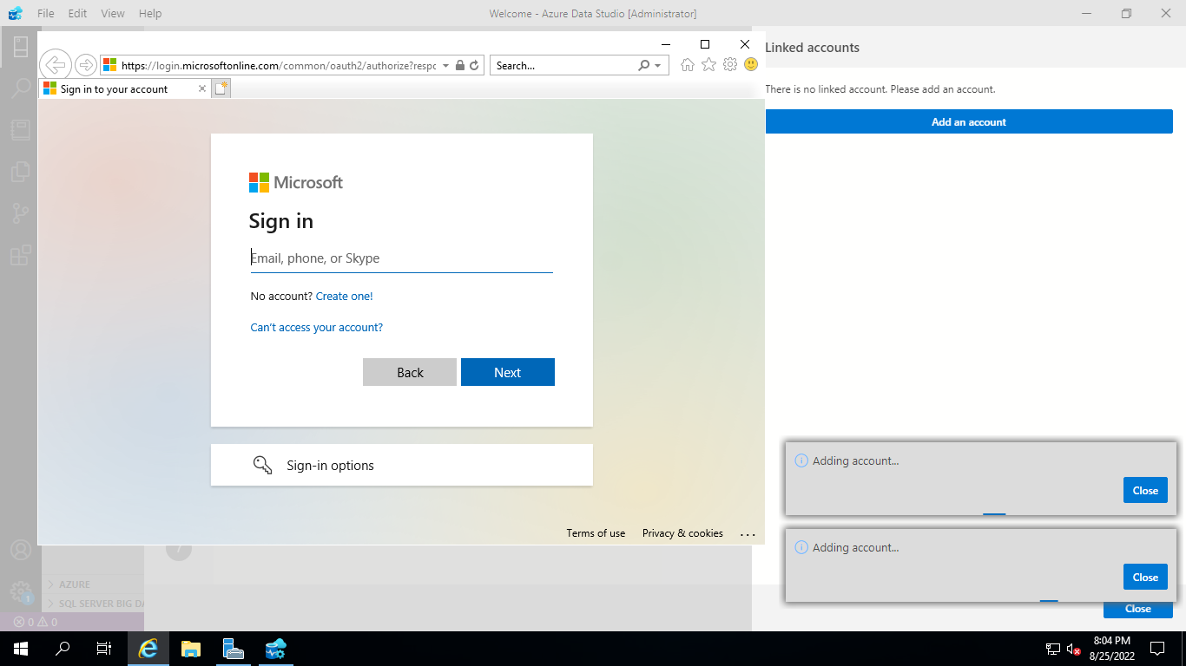

Provide Azure Portal Login Details

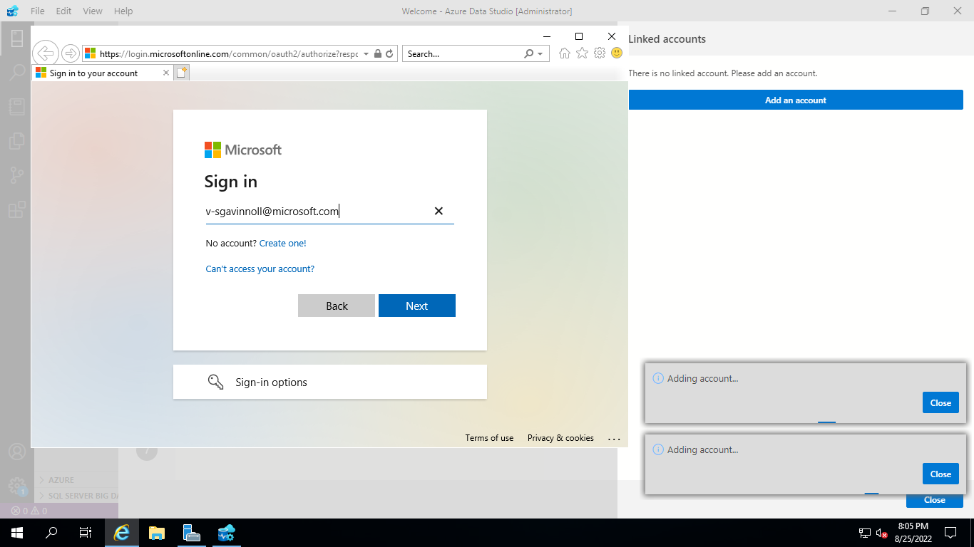

Once you are logged in then click close

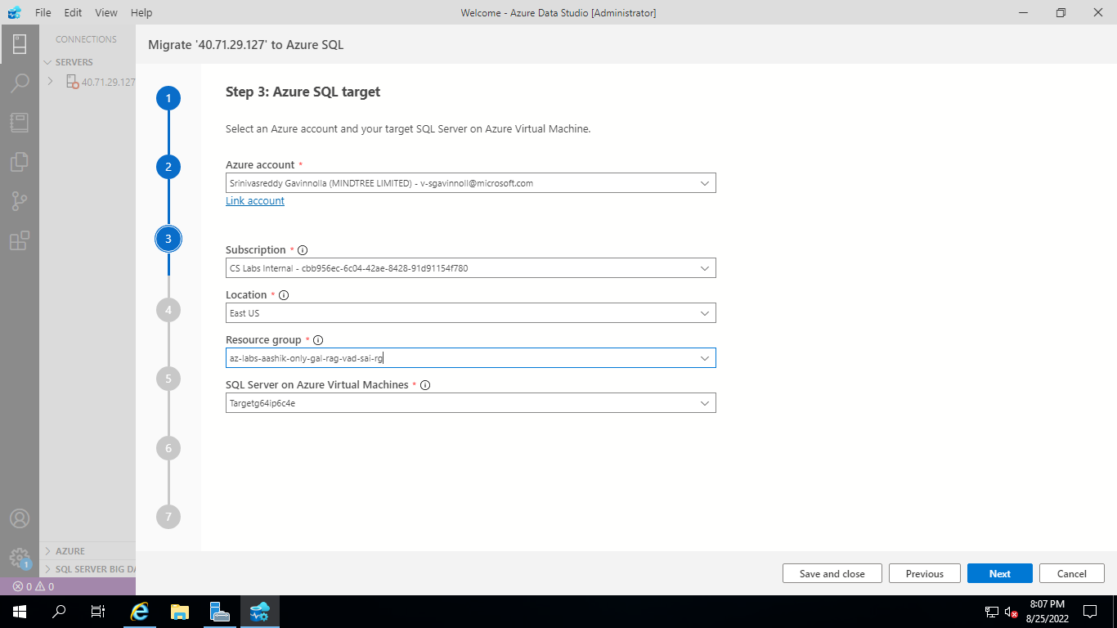

Click Next

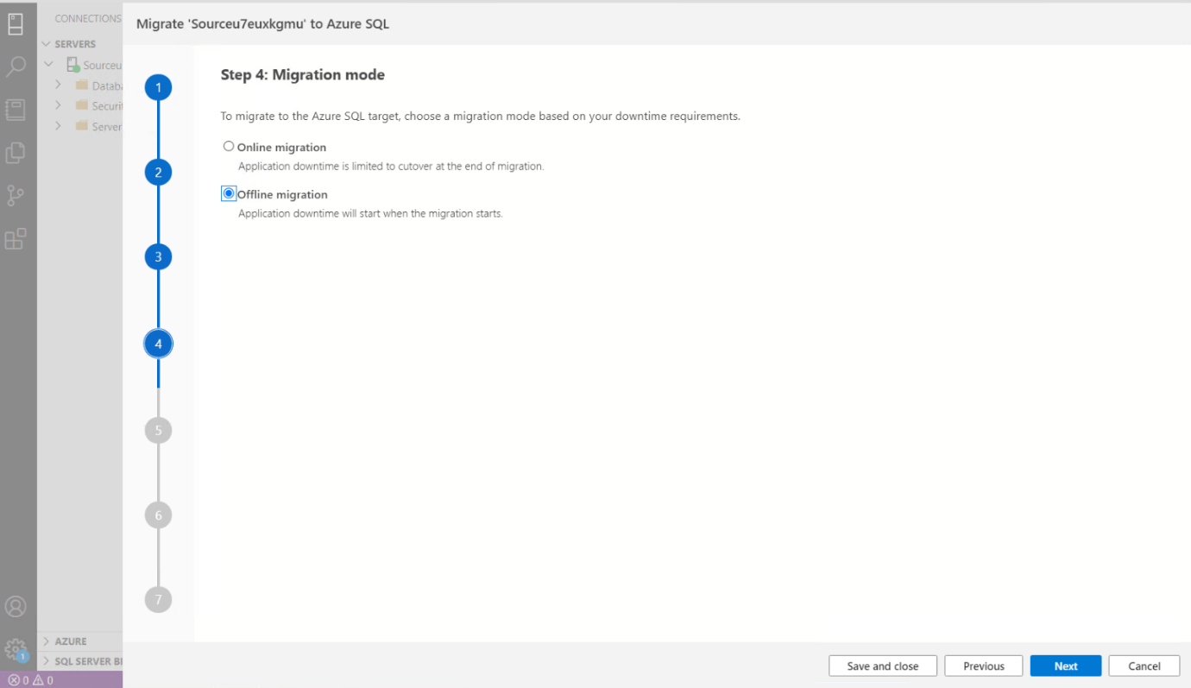

Select Offline Migration

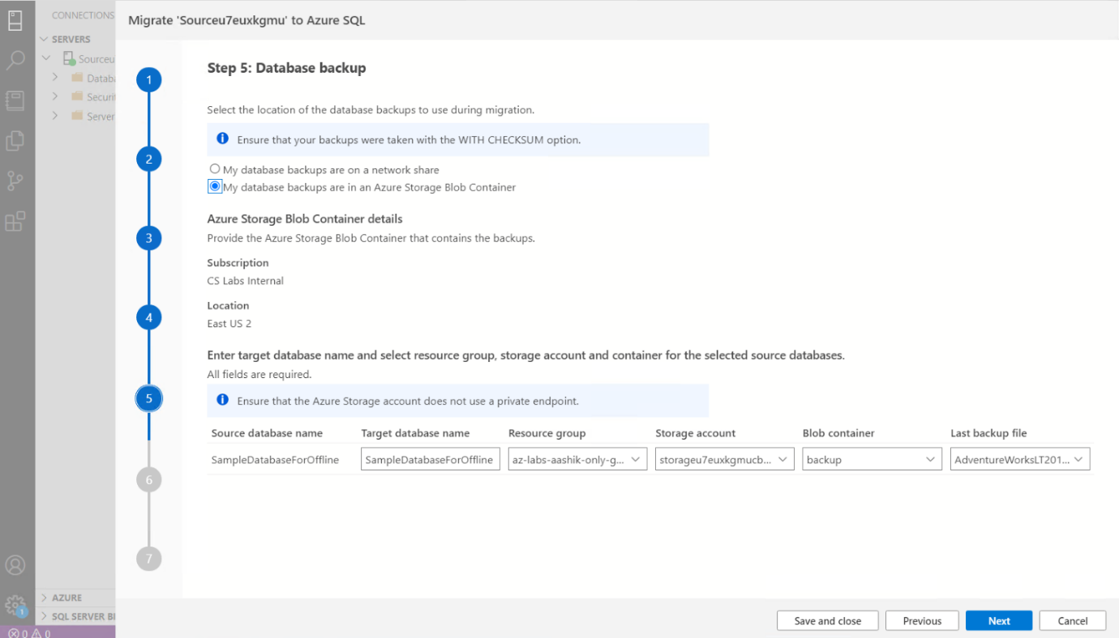

1.Select **Offline migration** as the migration mode.

2.Select the location of database backups. Source database backup in an Azure storage blob container.

3.For backups stored in an Azure storage blob container specify the below details of the **Target database name**, **Resource group**, **Azure storage account**, **Blob container** and **Last backup file from** the corresponding drop-down lists.

|  |  |
| --- | --- |
| **Field** | **Description** |
| **Target database name** | The target database name can be modified if you wish to change the database name on the target during the migration process. |
| **Storage account details** | The resource group, storage account and container where backup files are located. |
| **Last Backup File** | The file name of the last backup of the database that you are migrating. |

Provide Storage Account Blob Container details

Resource Group

Storage Account

Blob Container

Then Click Next  
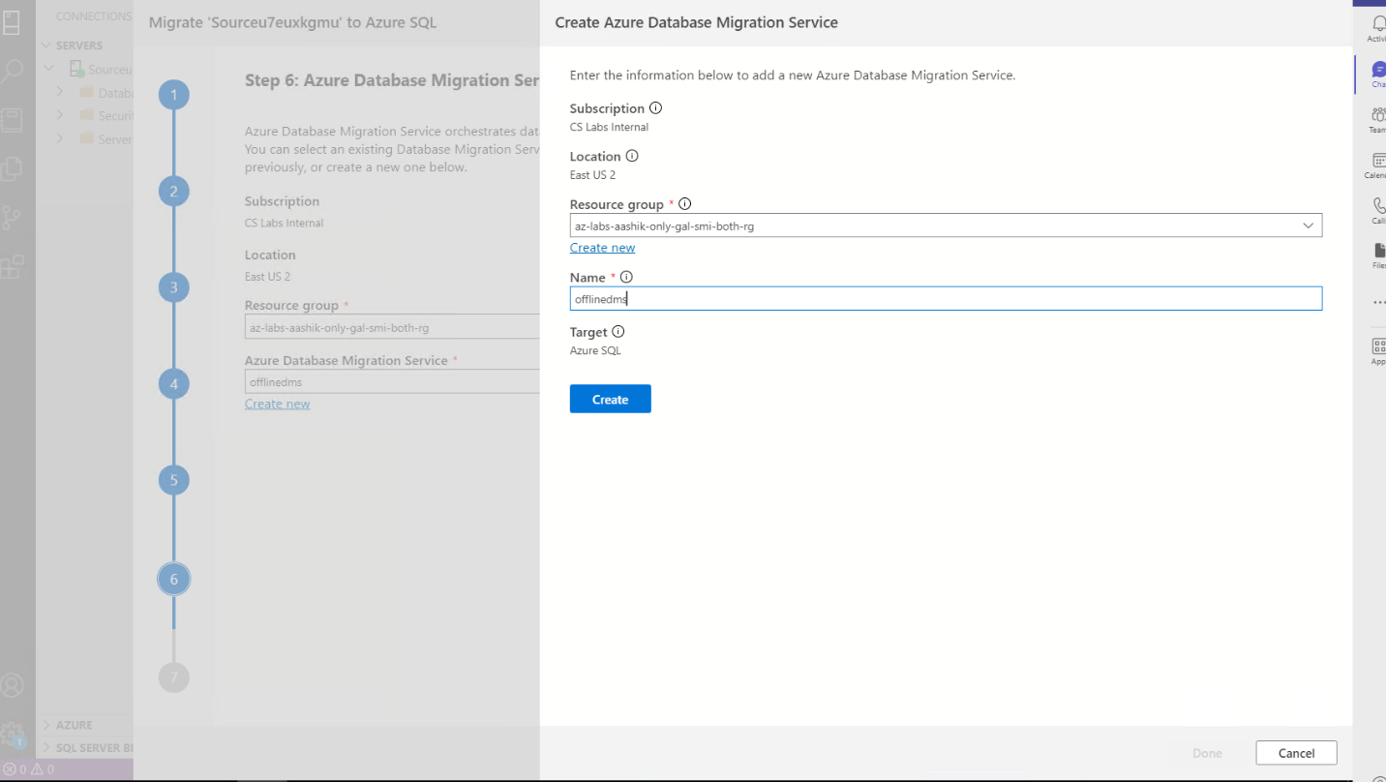

**Create Azure Database Migration Service**

1. Create a new Azure Database Migration Service or reuse an existing Service that you previously created.

**Note:**  If you had previously created DMS using the Azure Portal, you cannot reuse it in the migration wizard in Azure Data Studio. Only DMS created previously using Azure Data Studio can be reused.

2. Select the **Resource group** where you have an existing DMS or need to create a new one. 3. The **Azure Database Migration Service** dropdown will list any existing DMS in the selected resource group.

4. To reuse an existing DMS, select it from the dropdown list and the status of the self-hosted integration runtime will be displayed at the bottom of the page.

5. To create a new DMS, select on **Create new**.

6. On the **Create Azure Database Migration Service**, screen provide the name for your DMS and select **Create**.

**Note : Please Provide the name of new DMS as ‘offlinedms’**

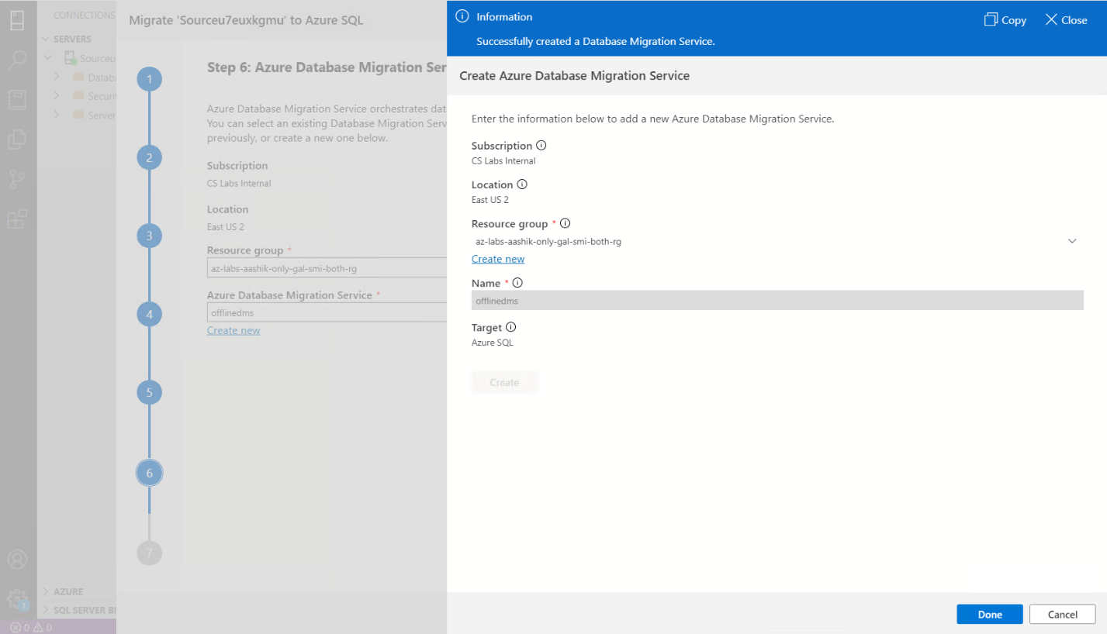Click Done

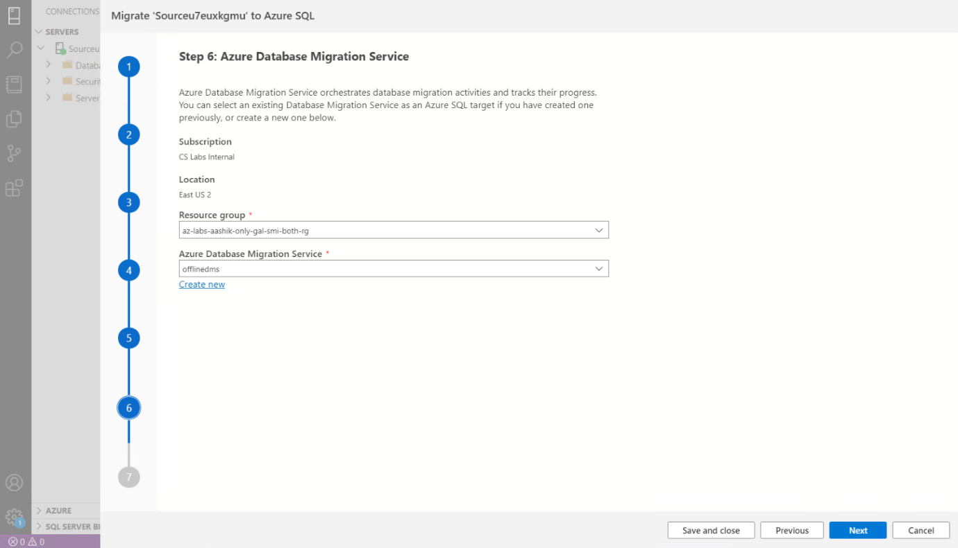

Click Next

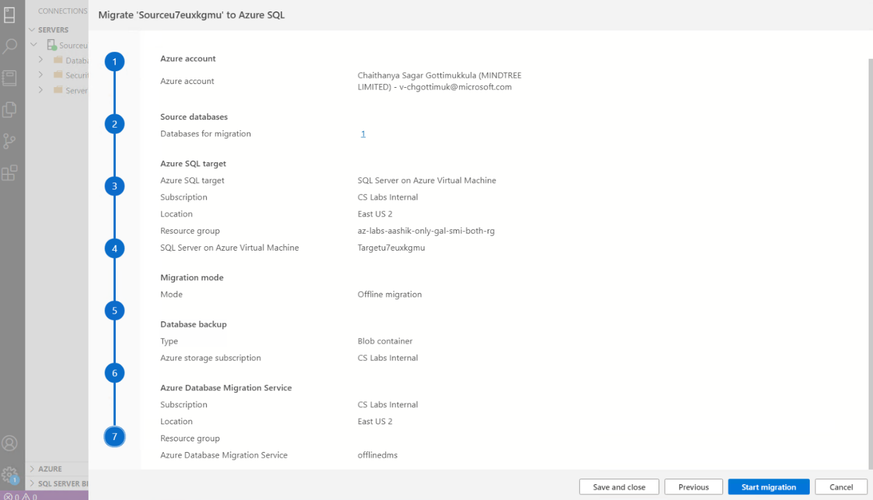

Start Migration

   
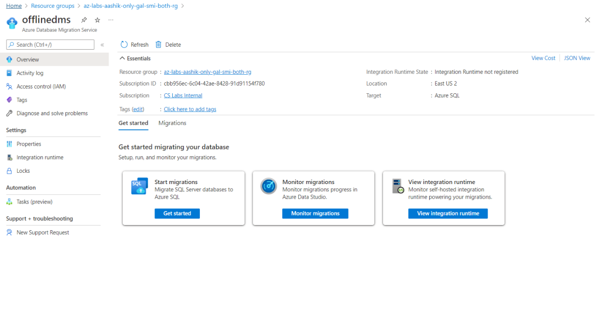

**Monitor the migration**

Open **‘offlinedms’** and select **Monitor migrations**

On the migration activity screen, select **Refresh** to update the display until the **Status** of the migration shows as **Completed**.

**Monitor your migration**

On the **Database Migration Status**, you can track the migrations in progress, migrations completed

  
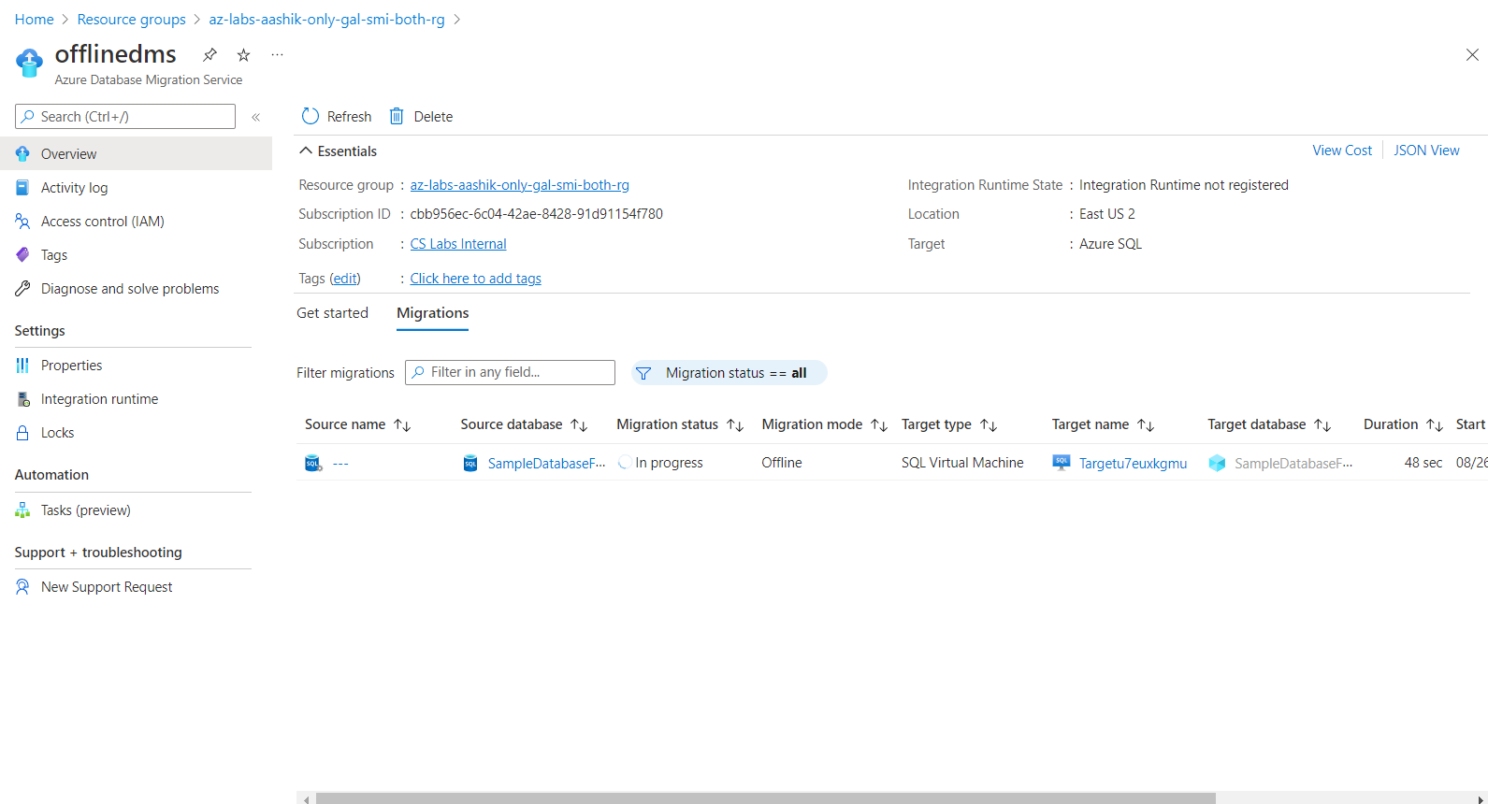

Hit Refresh

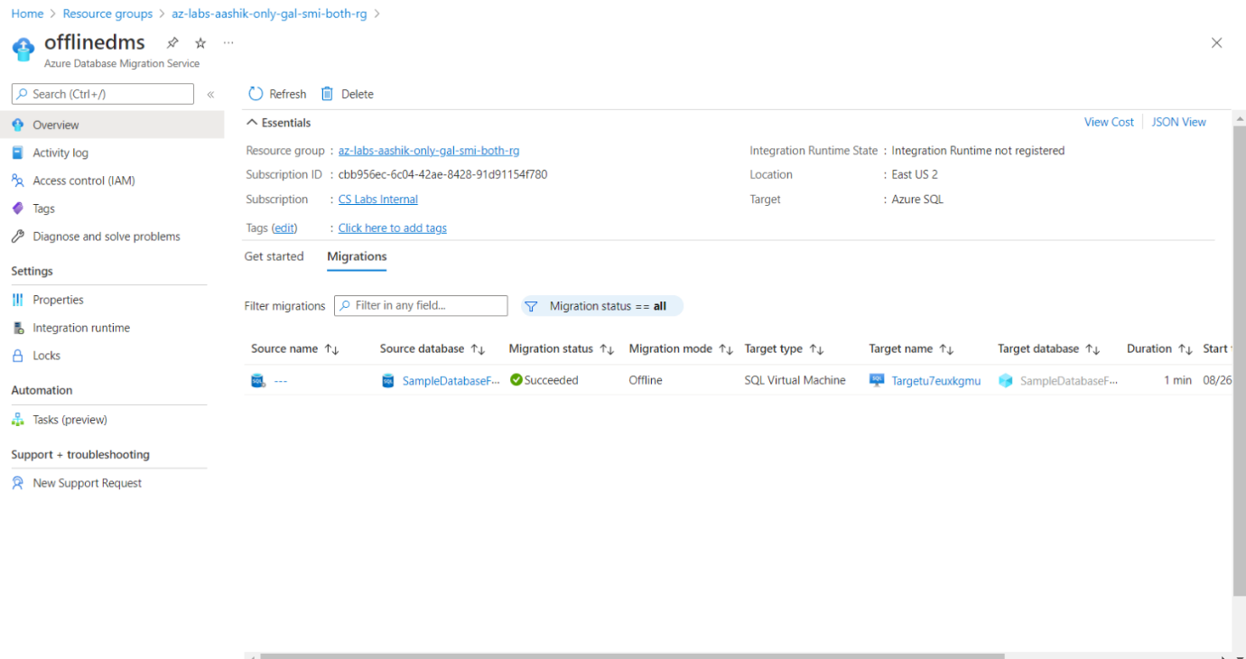

**Post Migration Validation Steps**

Login to target VM using RDP.



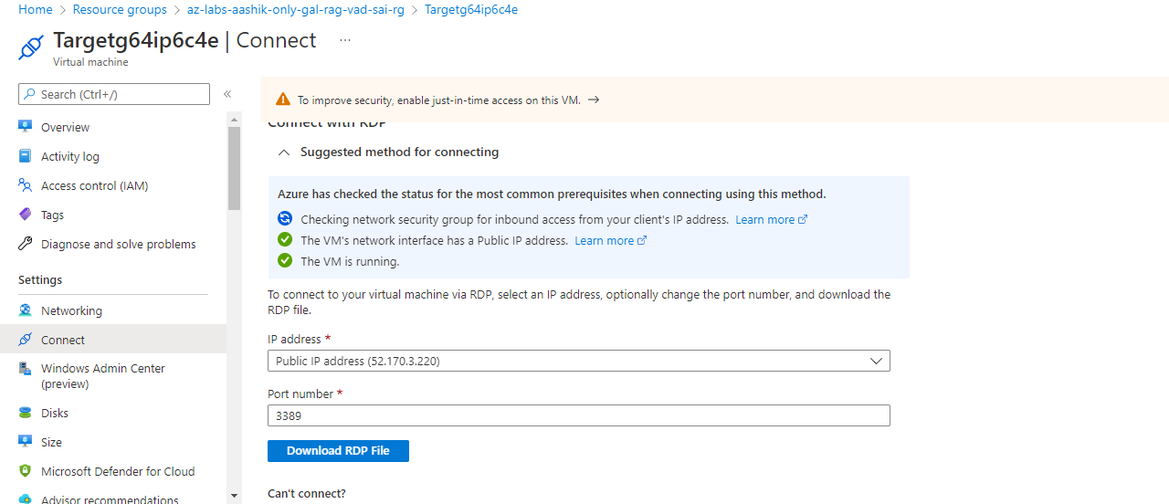

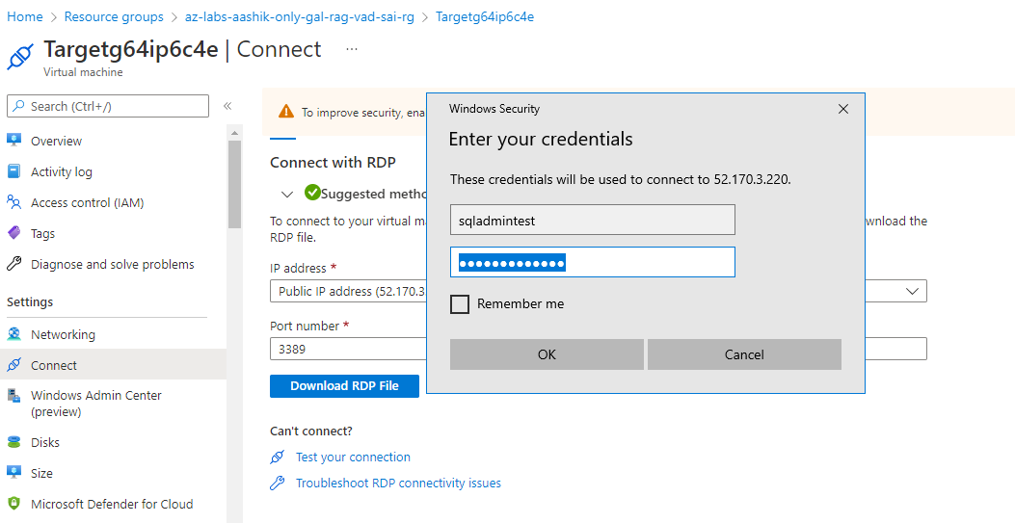

Search for **Microsoft SQL Server Management Studio** from Start

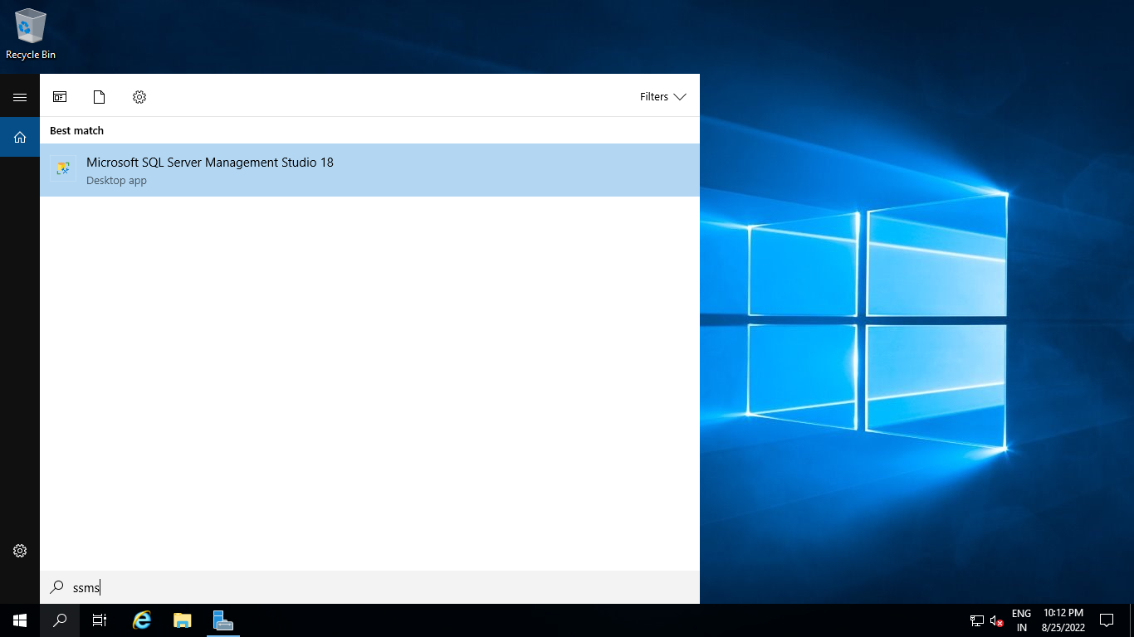

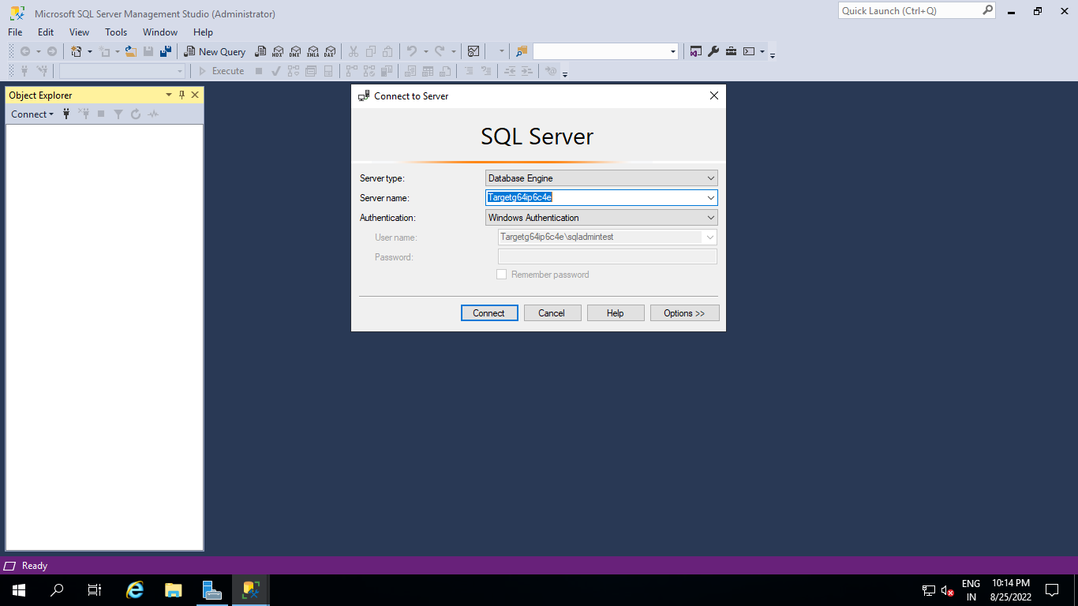

1. **Execute below SQL Query:**

Query:

select schema_name(tab.schema_id) + '.' + tab.name as [table],

sum(part.rows) as [rows] from sys.tables tab

inner join sys.partitions part on tab.object_id = part.object_id

where part.index_id IN (1, 0)

group by schema_name(tab.schema_id) + '.' + tab.name

order by sum(part.rows) desc

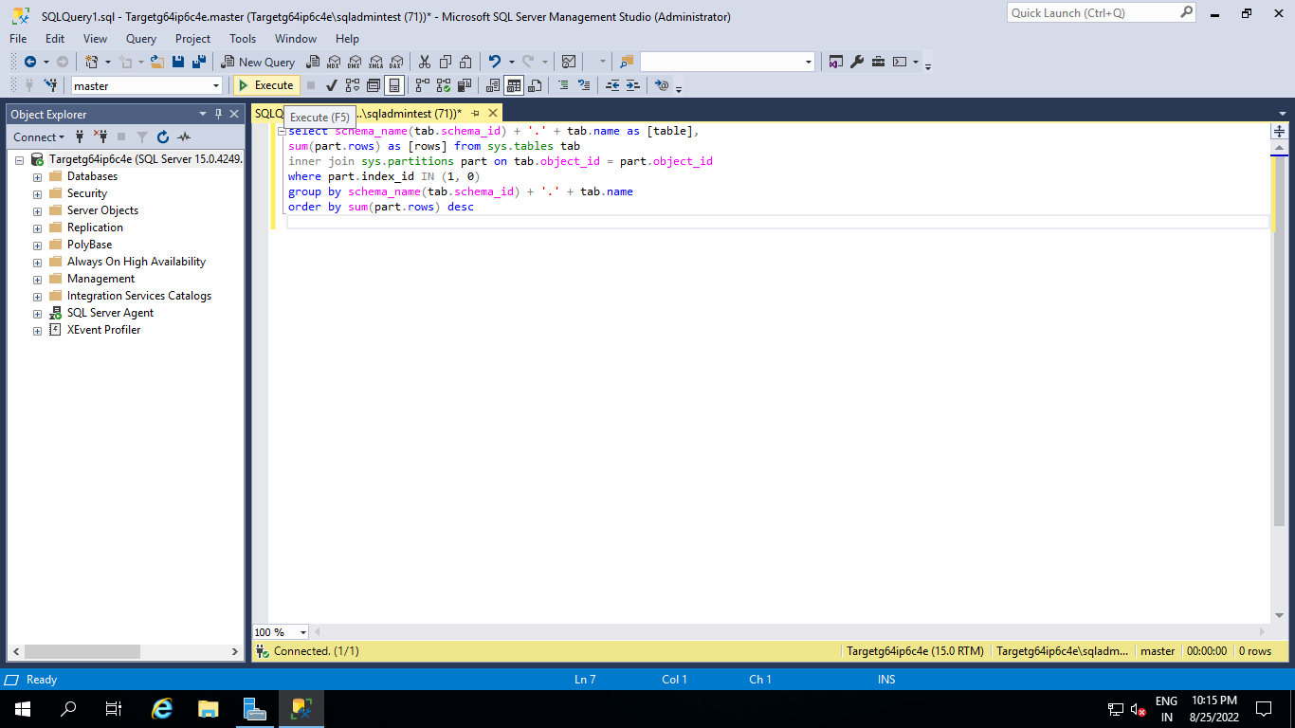

Please validate output with below parameters.

**Output:**

table, rows

SalesLT.Customer,847

SalesLT.ProductDescription,762

SalesLT.ProductModelProductDescription,762

SalesLT.SalesOrderDetail,542

SalesLT.Address,450

SalesLT.CustomerAddress,417

SalesLT.Product,295

SalesLT.ProductModel,128

SalesLT.ProductCategory,41

SalesLT.SalesOrderHeader,32

dbo. BuildVersion,1

dbo.ErrorLog,0